WEEKLY HIGHLIGHTS July 19, 2024
This is the last week of most of our Summer of Learning programs. Thank you for your extraordinary dedication and hard work in coordinating and delivering successful instructional and enrichment summer programs. Your commitment to providing high-quality education and engaging activities has made a significant impact on the lives of countless students. Through your creativity, passion, and tireless efforts, you have fostered a love for learning and exploration, ensuring that students not only kept pace academically but also enjoyed a fun and enriching summer. Your contributions have made a lasting difference, and we are deeply grateful for your unwavering dedication to our students' growth and success.

- 96,309* unique student enrollment for all Summer of Learning Programs (as of 7/19/24)

SUMMER SCHOOL SURVEYS
As we close summer programs, we would like your feedback. Your opinion matters to us, and we strive to continuously improve our programs and services based on our stakeholders' valuable feedback.

- Please distribute survey fliers with QR codes to staff, students(Grades 4-12), and families.
- Click the appropriate link for access to the surveys: bit.ly/SummerSchoolSurvey2024

For more information, please contact Tyra Henderson, Director of Elementary Instruction at tbrookin@lausd.net.


SUMMER CONTINUITY OF LEARNING FUN
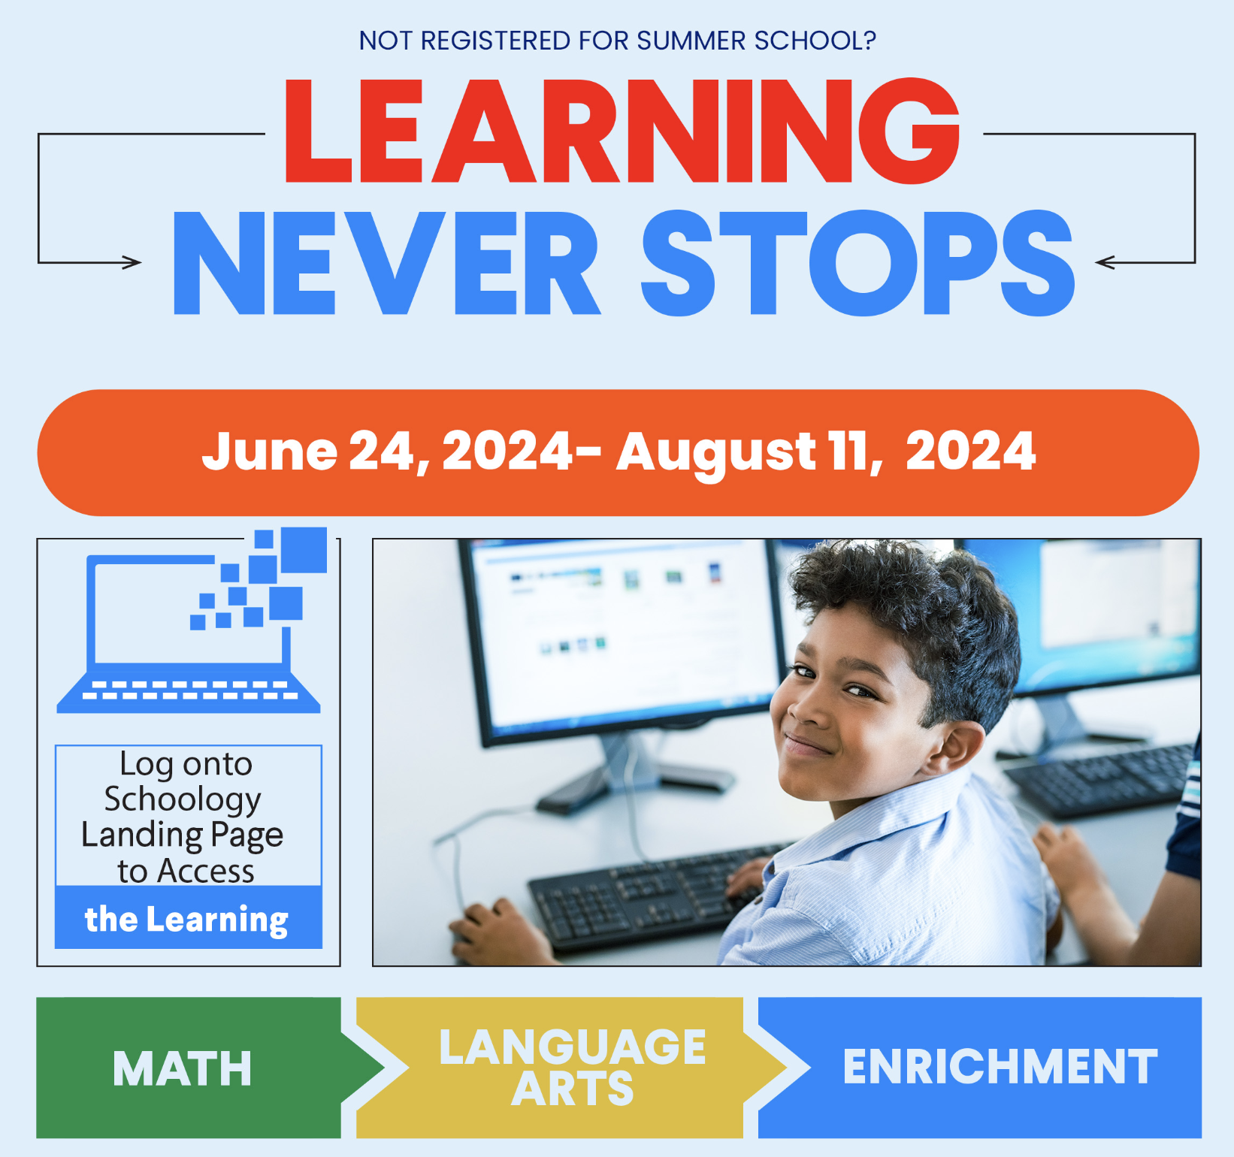
Although in-person Summer of Learning programs have ended, Continuity of Learning lessons continue to be available until August 11, 2024.
- 87,457 unique users have accessed Continuity of Learning Lessons (as of 7/19/24)
- Unique participation by region: North 29,827, South 19,153, East 25,660, West 11,603, XS-1,214
- 📺 How to access learning activities: Video

For more information, please visit our Summer School website: Website or contact Tyra Henderson, Director of Elementary Instruction at tbrookin@lausd.net.

#LAUSD #SummerLearning #KeepLearning #EducationForAll

SUMMER SCHOOL, UTK-8
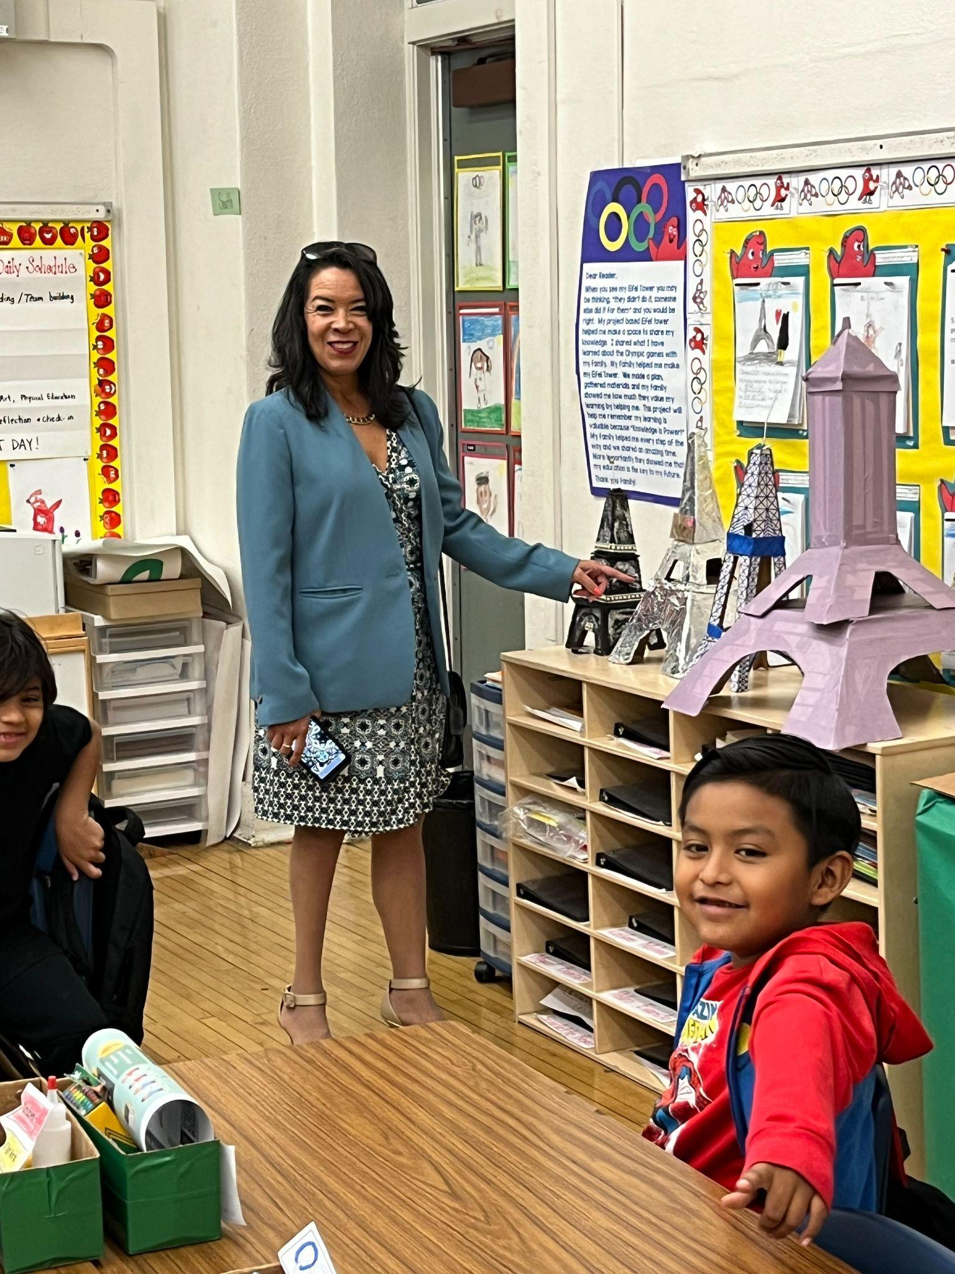
A heartfelt thank you goes out to our UTK-8 principals, teachers, and staff involved in making our summer program a resounding success. Many thanks to our Region and central office partners for their ongoing collaboration, support, and valuable contributions. Your leadership, hard work, and dedication is what made the Summer School UTK-8 program such an enriching experience for all.

This year, approximately 24,000 students attended the Summer School UTK-8 program. Over the course of the 20-day program, students received core instruction and targeted academic intervention, participated in hands-on arts and sciences enrichment activities, and experienced a Day of Discovery field study. Additionally, 98 students at LA Academy Middle School received a free vision care screening through the Helen Keller California Vision Program. Thirty-one students received a brand-new pair of glasses free of charge!

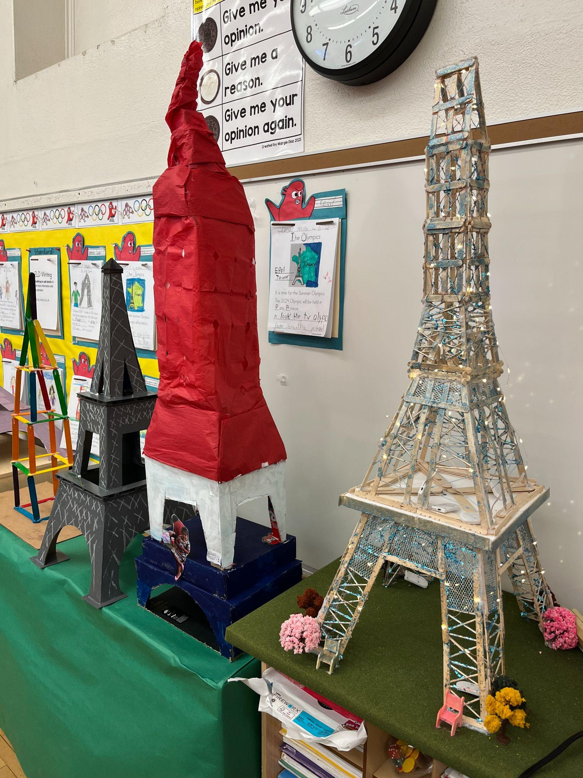
Here are some additional highlights for the Summer School UTK-8 program:

- 21,000 ELA Pre-Assessments completed district-wide for UTK-8 program students. (By Region: East: 6K, South 6K, North 5K, and West 3K)
- 20,000 Math Pre-Assessments completed district-wide for UTK-8 program students. (By Region: East: 6K, South 6K, North 5K, and West 3K)
- 3,993 classroom observations using the UTK-8 Classroom Observation Tool
- 168 Day of Discovery outdoor learning field study experiences provided for UTK-8 students
- 24,106 unique student enrollment for UTK-8 Programs (as of 7/19/24)

Building an Eiffel Tower replica is a fantastic way to celebrate the Summer Olympics in Paris!

For more information, please contact your Summer School Principal OR Ana Estevez, Director, Beyond the Bell, at ana.estevez@lausd.net. Thank you!

NEWCOMER PROGRAM
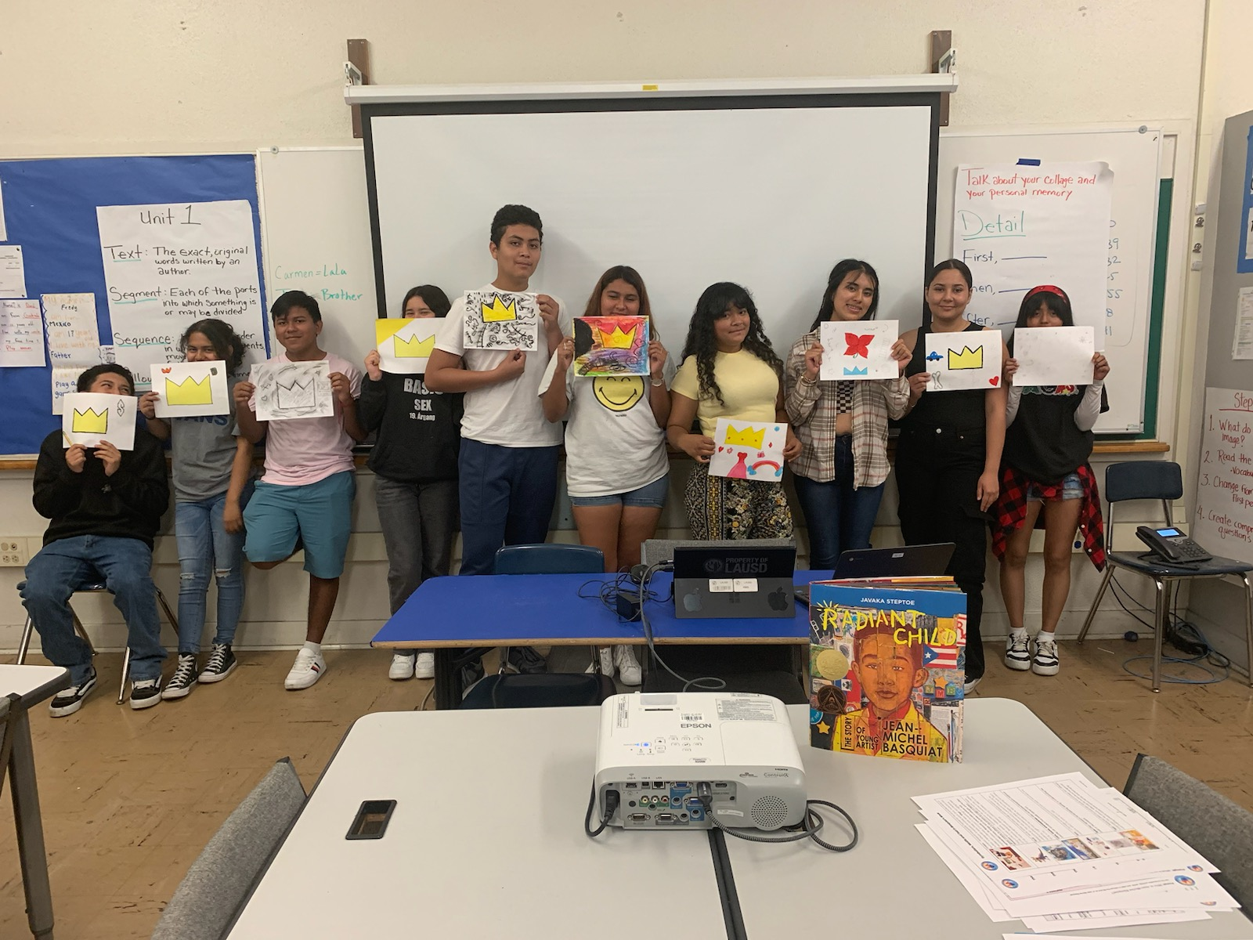
After 4-weeks of rigorous enrichment hands-on learning our International Newcomer students participated in our virtual culmination where we celebrated their accomplishments, and highlighted their academic growth throughout the 4 weeks of learning. Students felt empowered and reinvigorated in enriching their academic language through academic discourse.
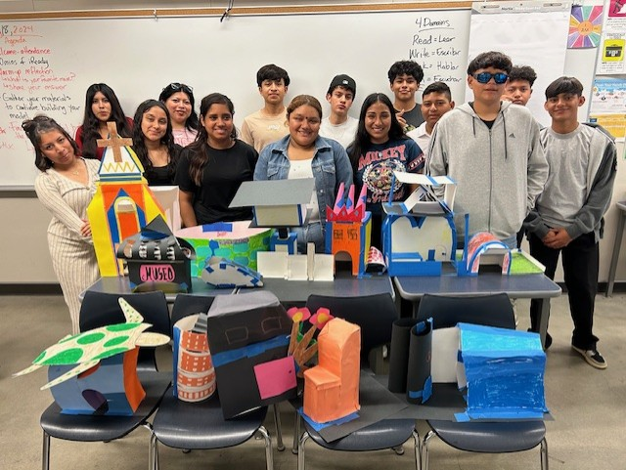
Our Executive Director, Lydia Acosta Stephens opened our culmination with inspiring words that resonated with the students and staff. She reminded them that they are all “tesoros” and that we need to stay true to who they are.
- 1,061 unique student enrollment for Newcomer Program (as of 7/19/24)
Click here to hear our student voices!
For more information, please contact Bernie Carrasco at @bcarrasc@lausd.net.

HIGH SCHOOL SUMMER TERM
As we prepare to close the program this week, we extend our gratitude to our school leaders, faculty, and staff who have worked tirelessly over the past 20 days to provide a safe learning environment where students can thrive. We also thank our Region and central office partners for their collaboration and support. Throughout the program, thousands of classrooms have been visited where we observed excitement as students diligently worked to recover credits and enthusiasm as teachers planned engaging lessons that incorporated Kagan cooperative learning structures to boost student communication, confidence, and interest.
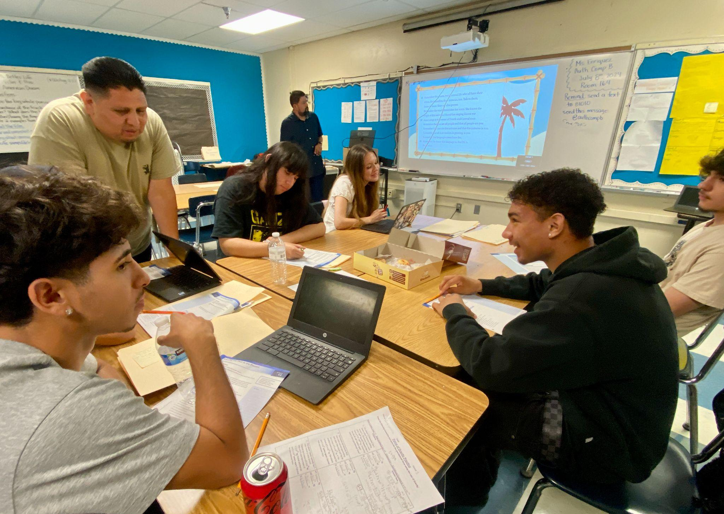
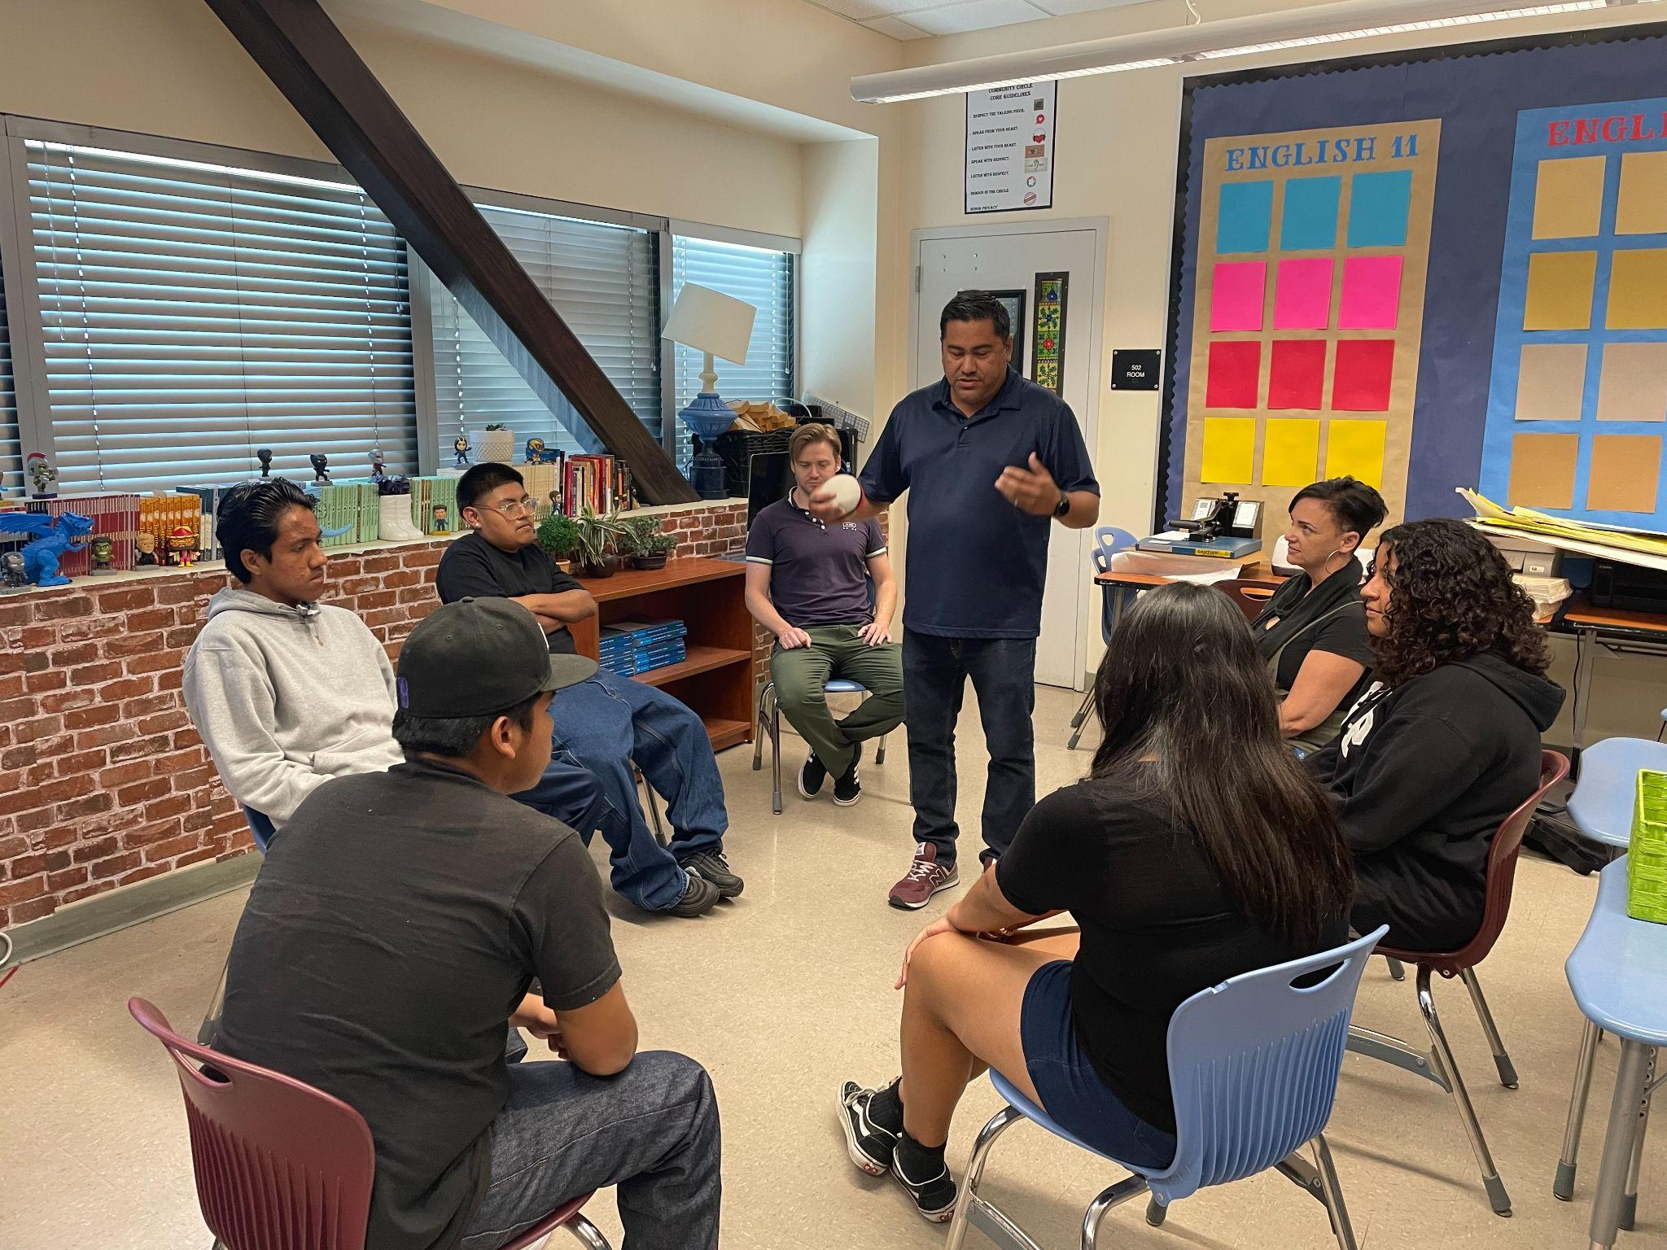
Huntington Park HS English students analyze poems written by rapper Tupac Shakur, discussing the overarching theme, and how the author’s language contributes to the poem’s message.

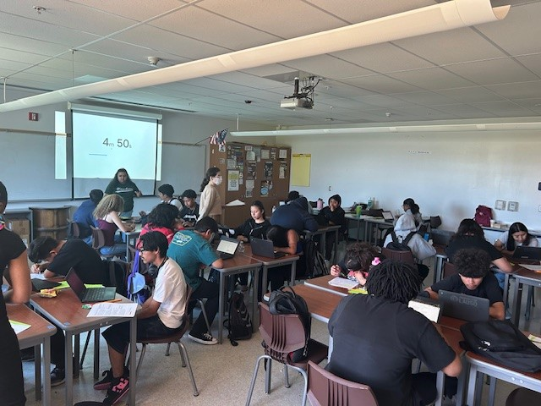
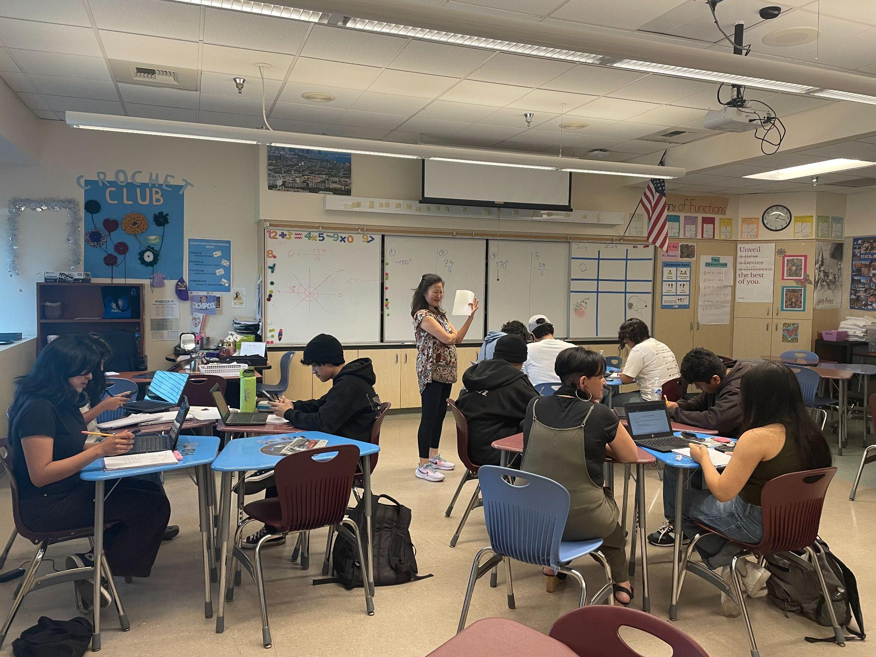
Bernstein HS teacher works on reference angles with student groups in a precalculus class while students discuss the problems within the group and conduct class presentations on their solutions. An English teacher conducts a community circle with students where they discuss the book Monster and share their personal experiences with the law.

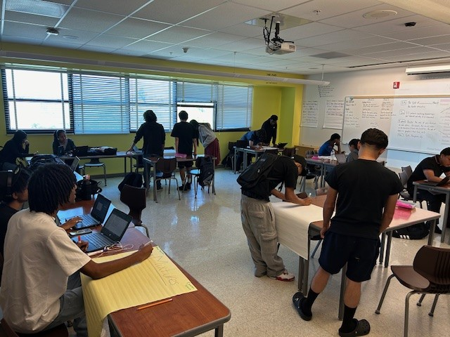
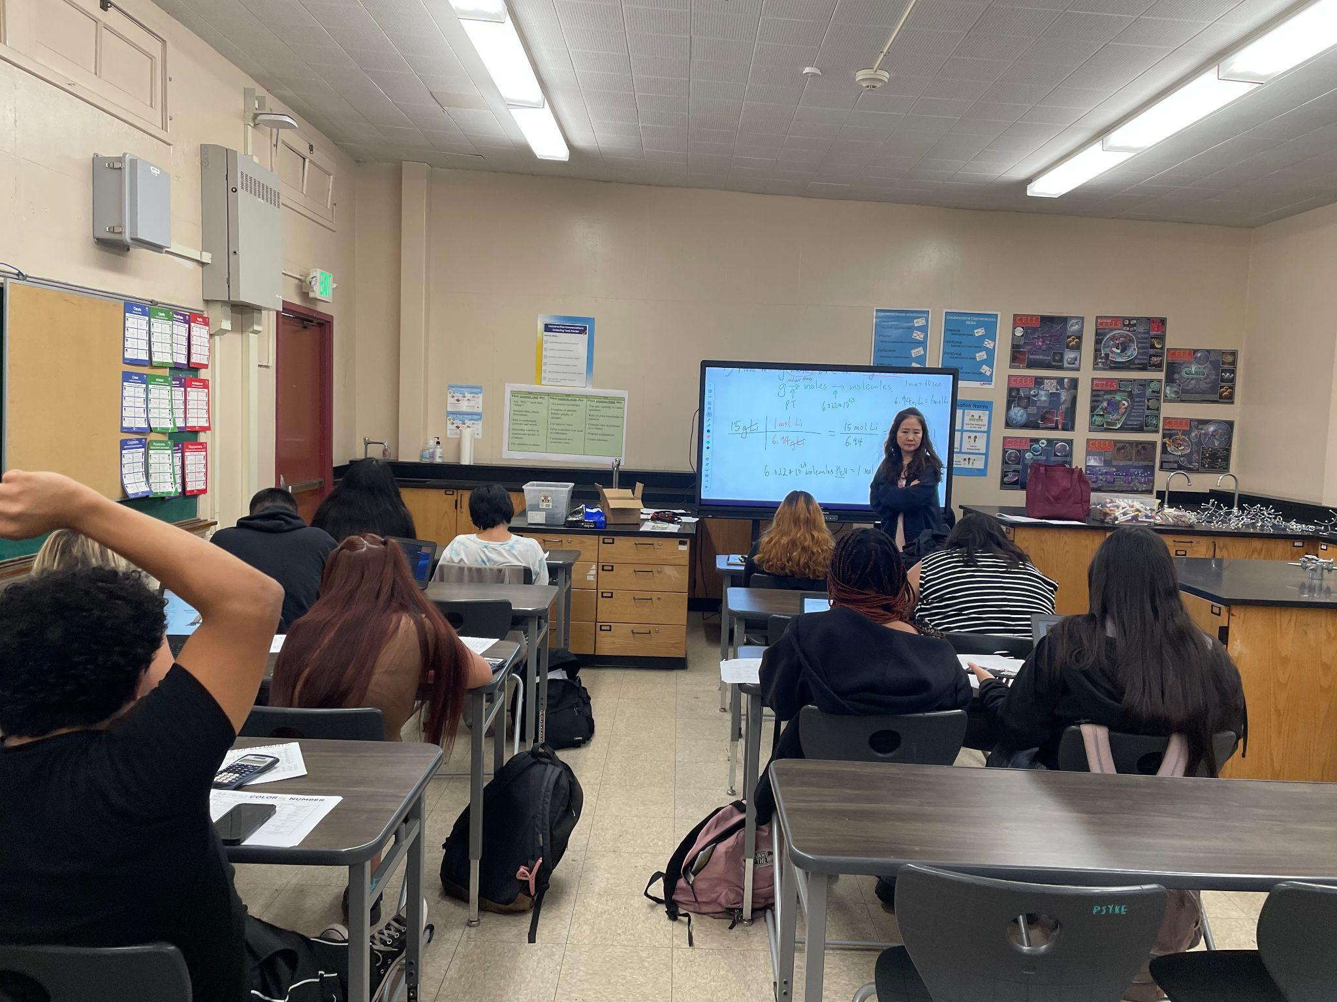
Hawkins HS students work together in groups as the teacher circulates the classroom checking for understanding by answering and asking questions. An English 9 class and a Chemistry B class are represented.

Van Nuys HS teacher works with chemistry students on solving word problems in which students convert grams to moles. Carolina kits are used for experiments and hands-on learning experiences.

- 2,156 classroom observations as of 7/19/24 using the High School Classroom Observation Tool
- 20,419 unique student enrollment for High School Summer Term In person (as of 7/19/24)
- 19,982 unique student enrollment for High School Summer Term Virtual (as of 7/19/24)
For more information, please contact your Summer School HS Principal, counselor, or Dr. Betsy Castillo, Director, Beyond the Bell at bac9874@lausd.net.

JO BOALER MATH CAMP
Students can dive into the exciting world of math by using multiple representations to uncover the patterns in the number of faces painted on sugar cubes. This thrilling activity has been a standout favorite for middle school students!
- 102 unique student enrollment for Jo Boaler Summer Math Camp (as of 7/19/24)

For more information, please contact Chiae Byun-Kitayama at cbyun1@lausd.net

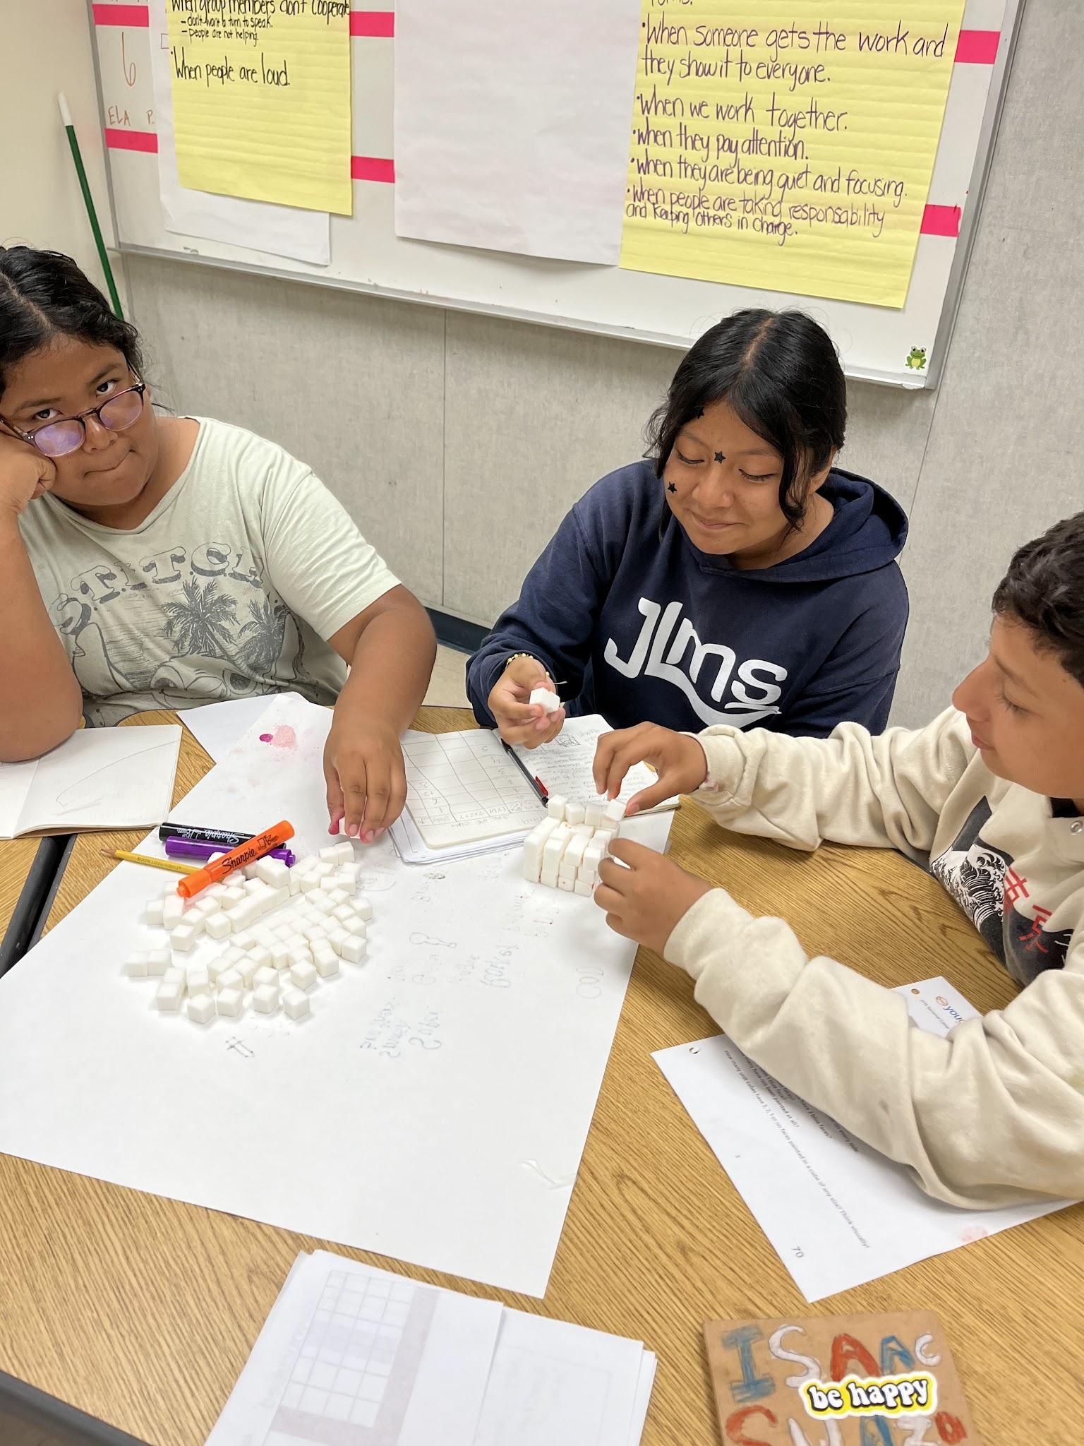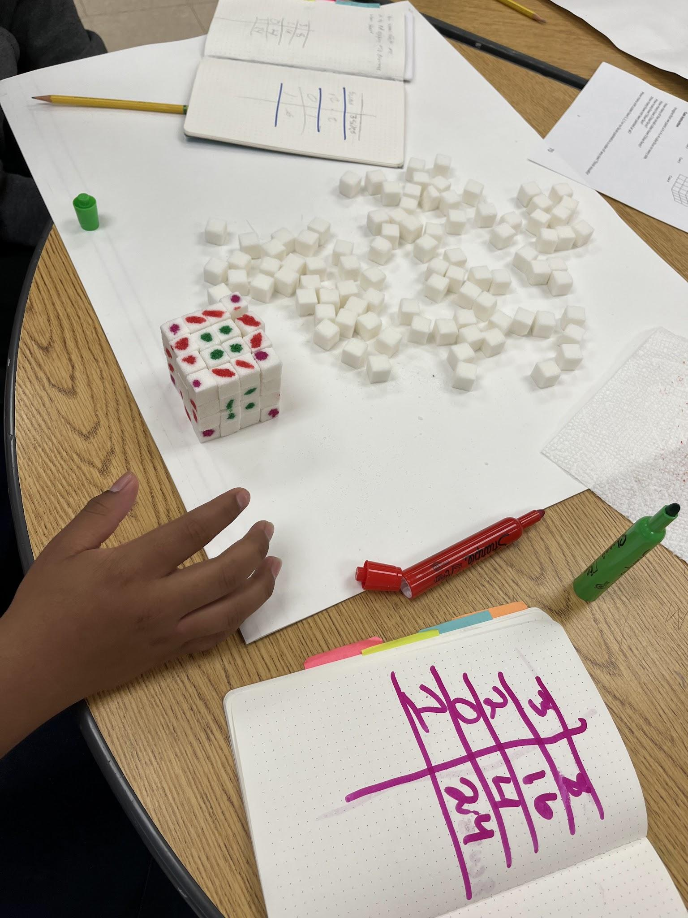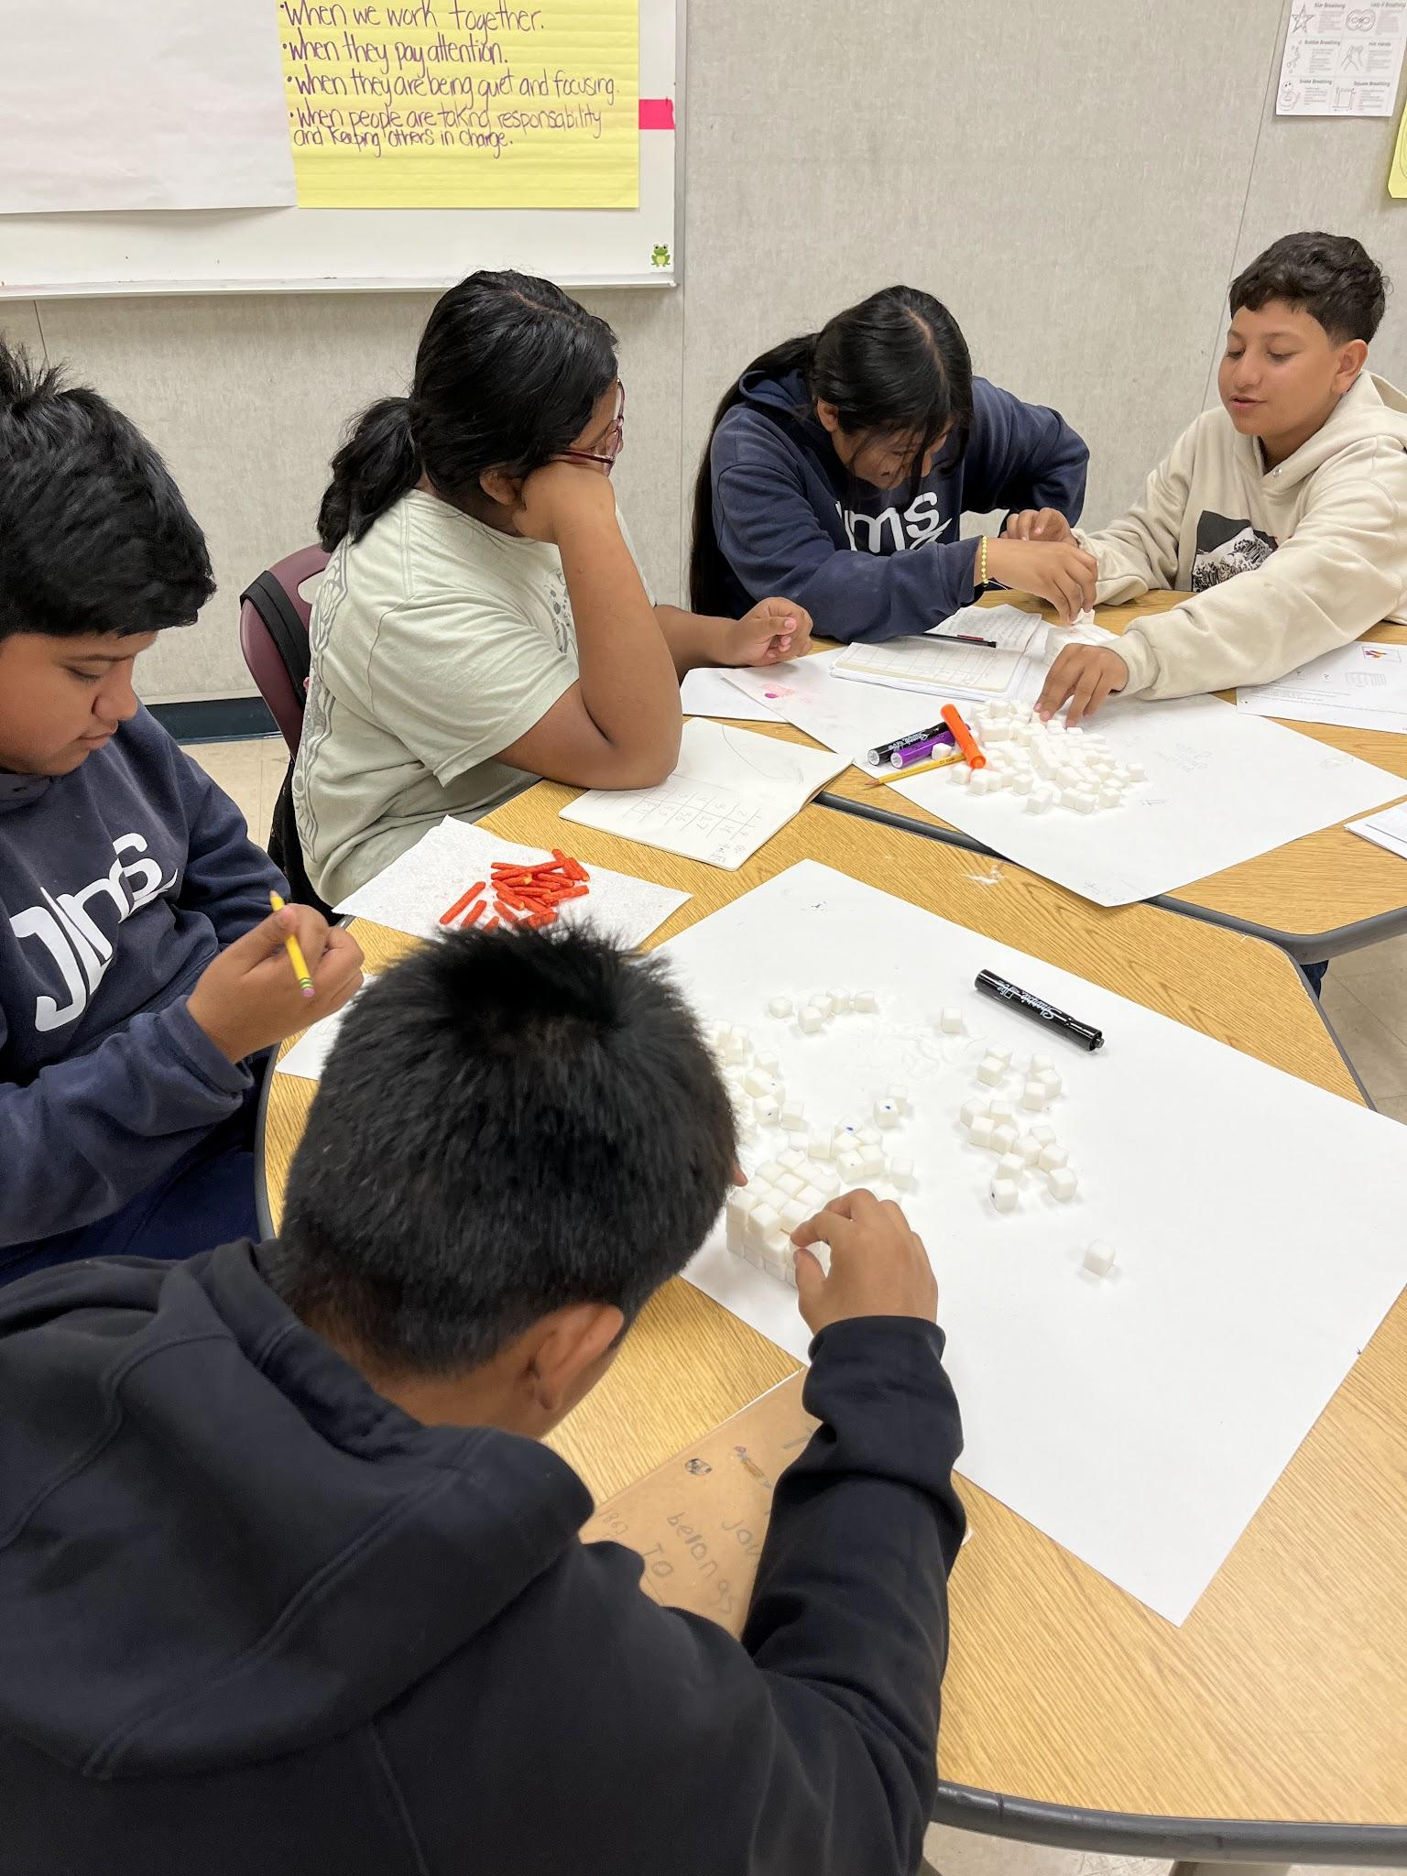

BRIDGE PROGRAMS
The Bridge Readiness Programs offer incoming middle and high school students a comprehensive readiness experience. These programs aim to prepare students for academic success, nurture their identity, foster new relationships, engage in social-emotional learning, and ignite motivation for the upcoming academic year.

- 60 MS, 52 HS and 18 Span Schools (130 Total) offering Bridge Readiness Program during summer
- 9,109 estimated unique student enrollment for upcoming July/August Bridge Programs (as of 7/19/24)
- Attendance for the week of July 19: 216 (3 schools offering programs this week)

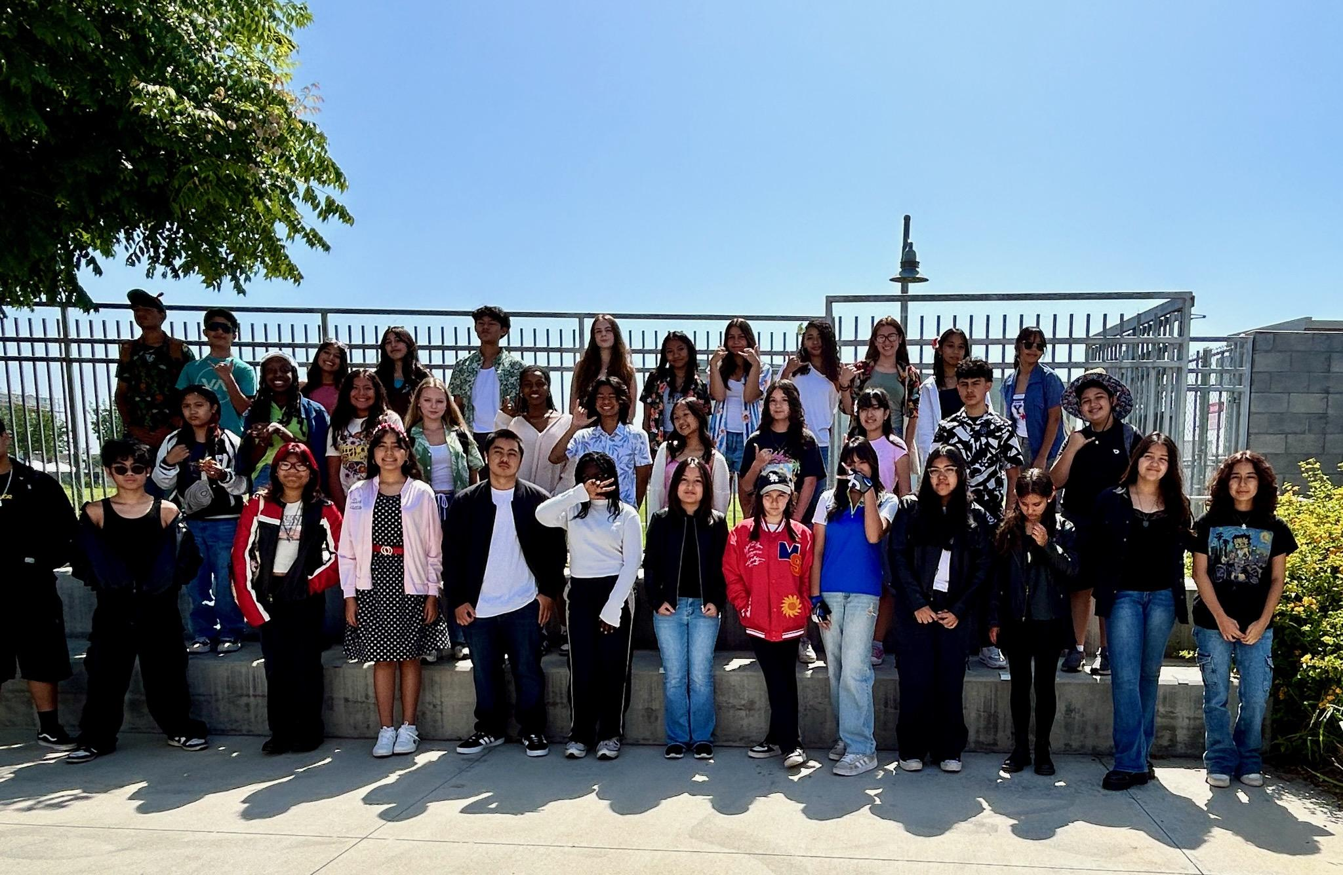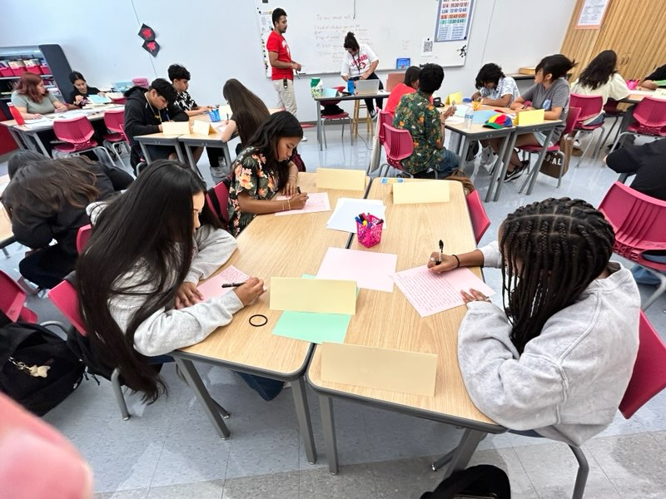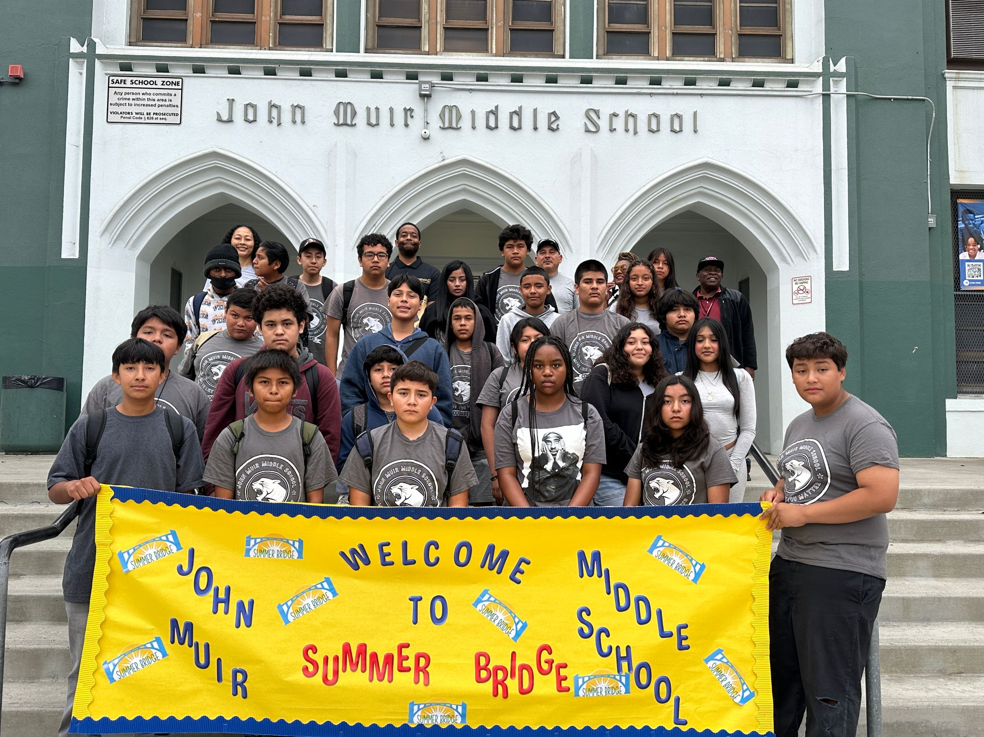

For more information, please contact Dr. Justin Lauer, Director of Middle School Instruction, jxl9505@lausd.net

LINKED LEARNING SUMMER BRIDGE
Linked Learning middle and high schools are welcoming their students by introducing them to their career pathways and project-based learning. Over 2200 students across the District participate in Linked Learning summer bridge programs allowing 40 Linked Learning pathways to get to know their new classmates, teachers, and campus and provide an academic challenge before the school year starts. They are even supported by older students who have the role of mentors and are paid interns.

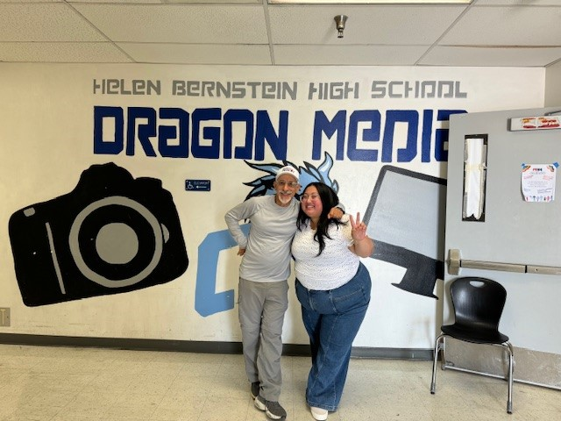
The summer bridge program in Bernstein High School Cinematic Arts and Creative Technologies Magnet’s Linked Learning career pathway led by teachers Mr. Kerbs and Ms. Santos (pictured) has been an outstanding experience for students and faculty. Check out this video made by the students.

For more information, please contact Susan Canjurasusan.canjura@lausd.net

STEAM CAMP @ THE SCIENCE CENTER
A Day of Discovery: Region North Students Explore Biomimicry at the California Science Center
A group of 129 excited students from Region North embarked on an inspiring field trip to the California Science Center during the LAUSD STEAM Camp, eager to dive into the world of biomimicry. The day promised a thrilling blend of science and adventure, and it delivered from the moment they set off.

As the students made their way to the Science Center, a serendipitous encounter with an engineer unfolded. This engineer, busy working on the housing structure for the iconic Endeavor space shuttle, took a moment to share insights about the creation and importance of the structure, captivating the young audience with real-world engineering marvels.

Upon arriving at the Science Center, the students' journey continued at the Air and Space exhibit. Here, they delved into the fascinating world of satellite and spacecraft design, learning about aerodynamics and the critical role of structural integrity in aerospace engineering. The exhibit sparked their curiosity and imagination, highlighting the incredible advancements that propel us into the skies and beyond.

The adventure didn't stop there. Next, the students ventured into the Eco Systems exhibit, where they experienced hands-on learning at its best. Touching and examining sea animals, they drew direct connections between nature and technology, discovering how biomimicry inspired the design of aircraft and spacecraft. The tactile experience of exploring sea creatures underscored the ingenious ways we borrow from nature to solve complex engineering challenges.

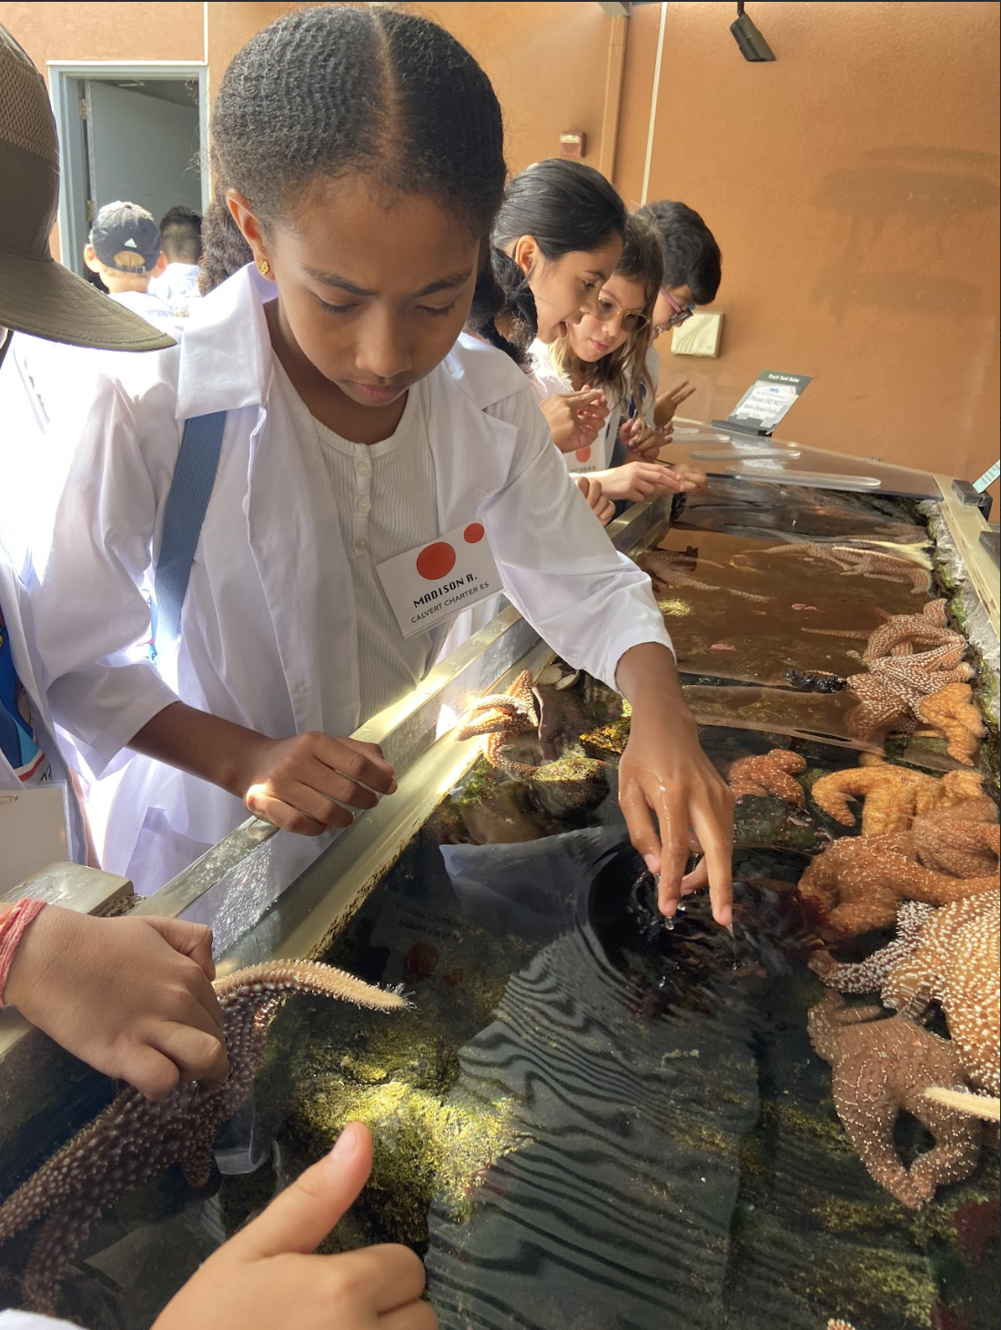
This unforgettable day at the California Science Center not only broadened the students' horizons but also ignited a passion for STEAM fields, proving that learning can be as exhilarating as it is educational.
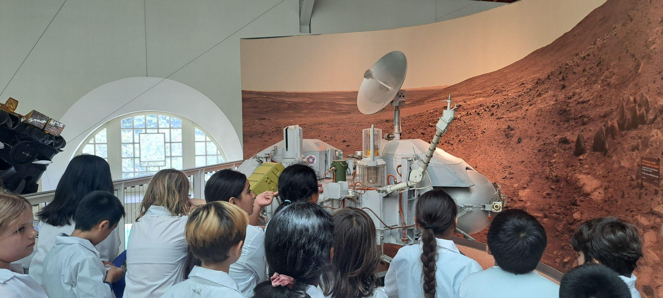
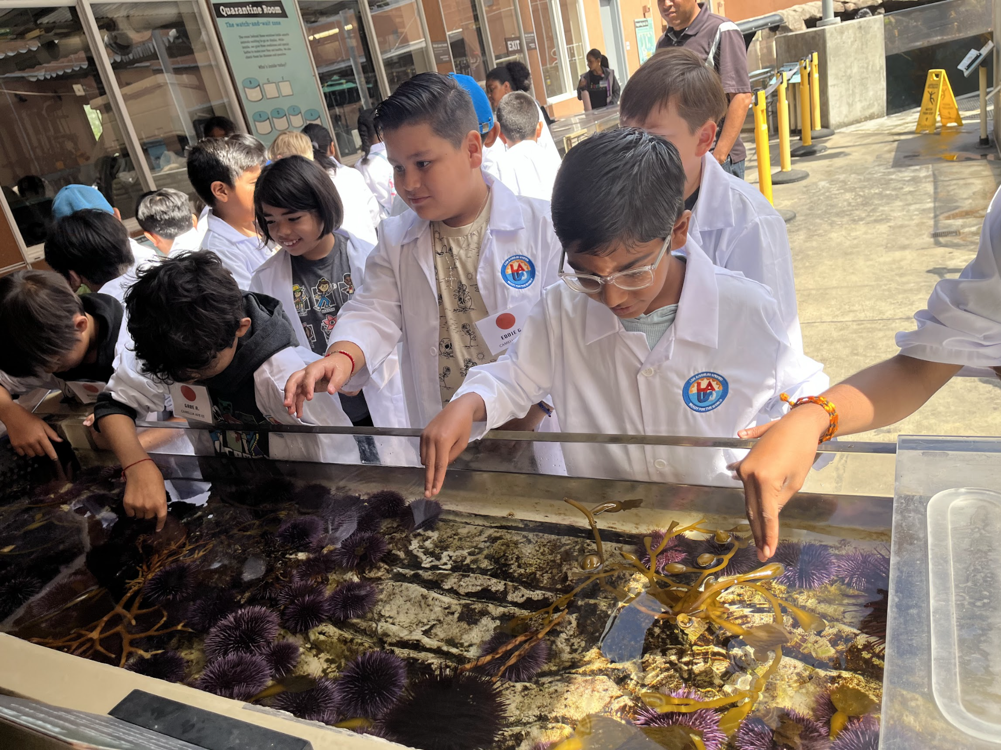
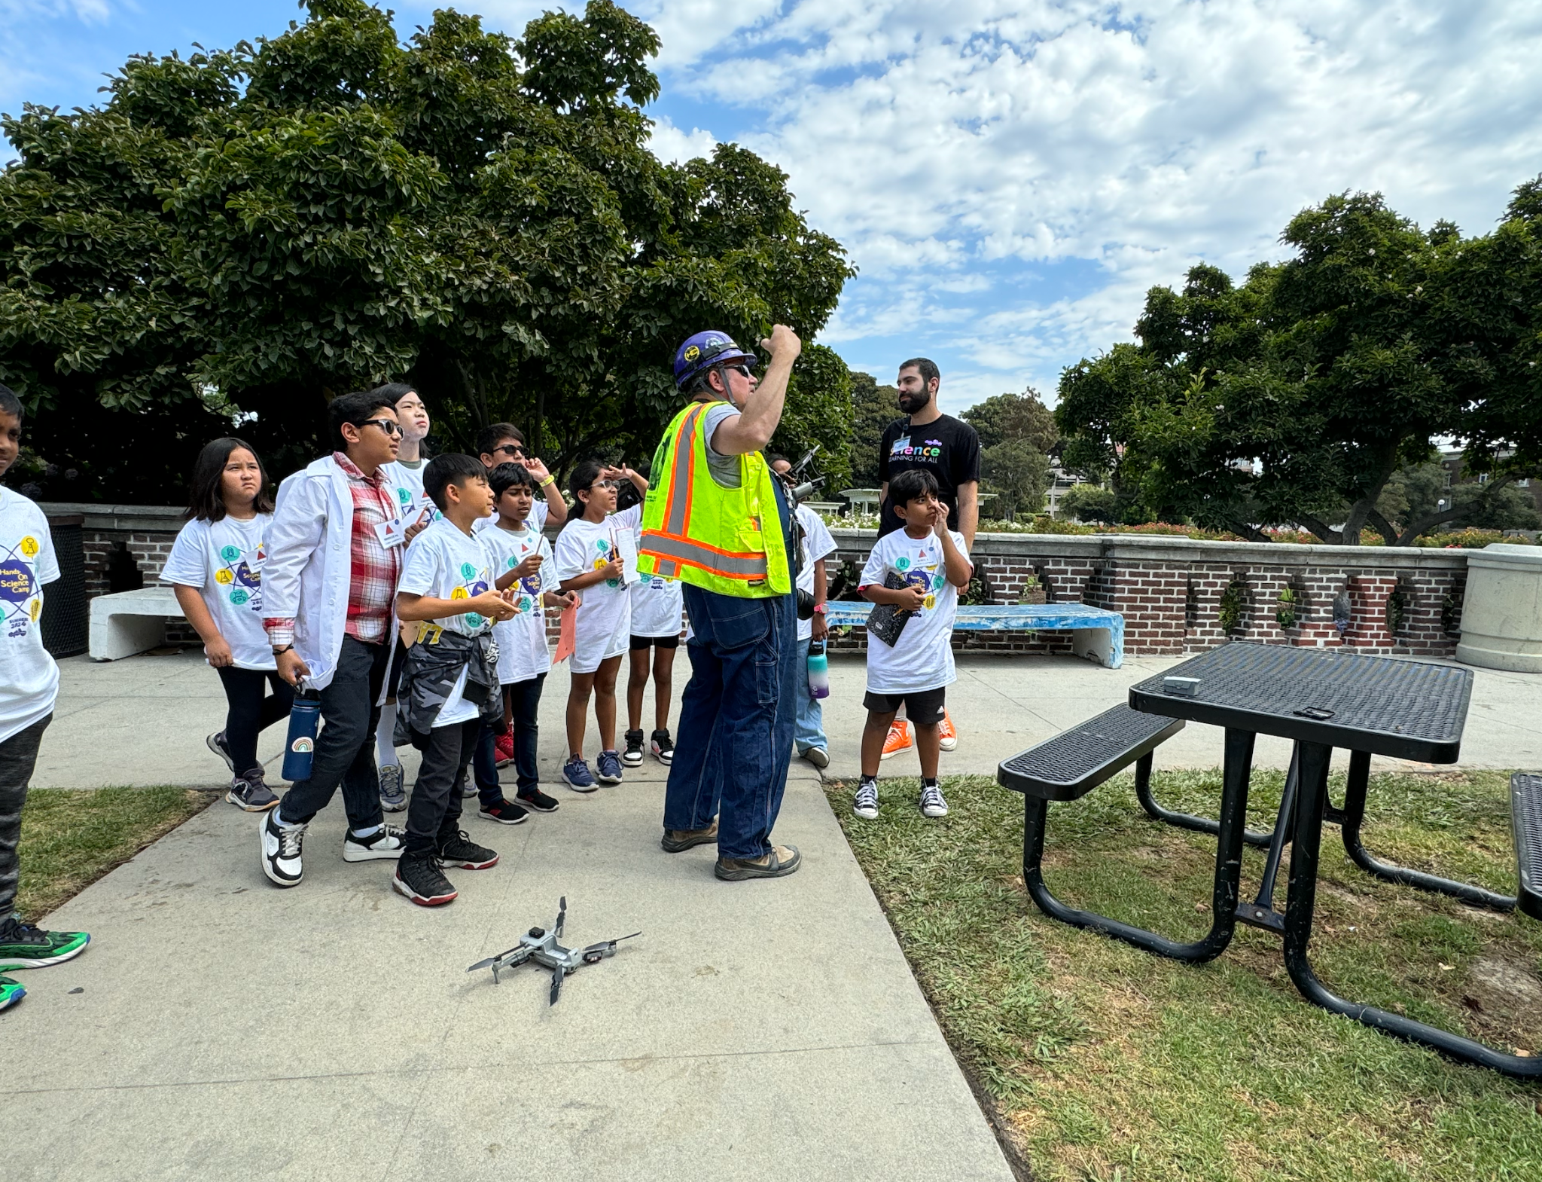

- 450 unique student enrollment for the STEAM Camp (as of 7/19/24)

For more information, please contact Jaspreet Sandha at jaspreet.sandha@lausd.net.

Extended School Year (ESY)
ESY is an IEP-determined service for students who require special education instruction or related services to prevent regression. Core ESY and ELOS use the same curriculum, including STEAM kits, PE, and Art enrichment materials. Alternate curriculum programs across grade levels focus on a service learning project developed by the students to increase their use of English, math, and social communication skills while making a difference in their school communities.

9,020 unique student enrollment for ESY (as of 7/19/24)
- Attendance = 8,719 as of 07/12/24
- Attendance = 8,737 as of 07/19/24
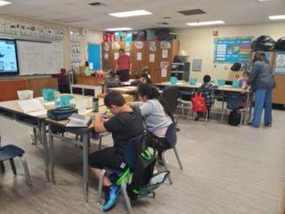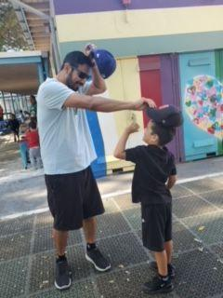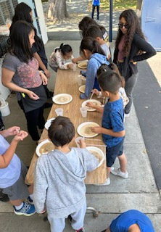
Above: students at Bertrand Elementary and Calahan Elementary Schools engaged in learning and having fun.

Below: students at Thomas Starr King MS had an ESY Culminating Activity of “Olympic Games” in which students participated in a variety of Olympic centers organized by teacher of the year Marci Kaye!
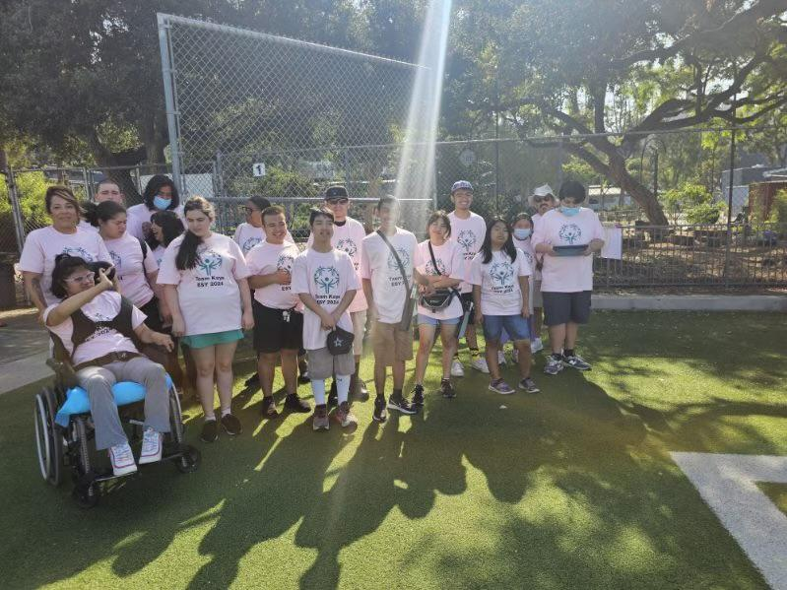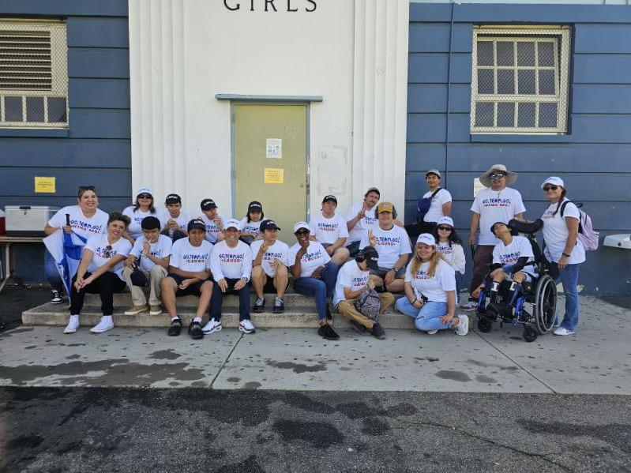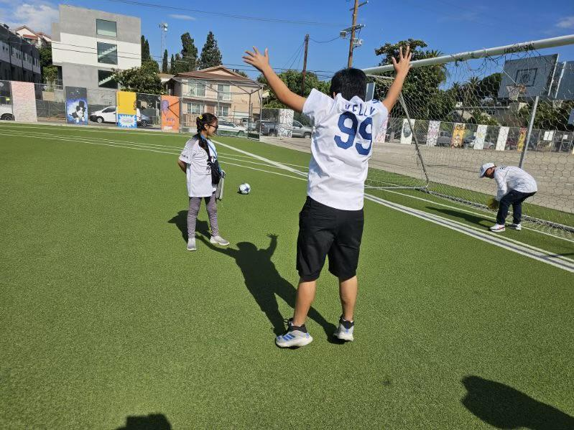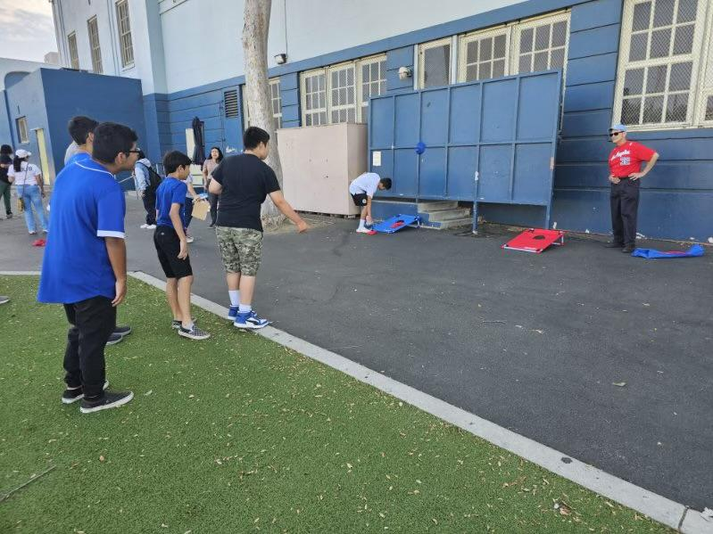

For more information, please contact the Division of Special Education, at esy@lausd.net or (213) 241-6701.

BEYOND THE BELL PROGRAMS

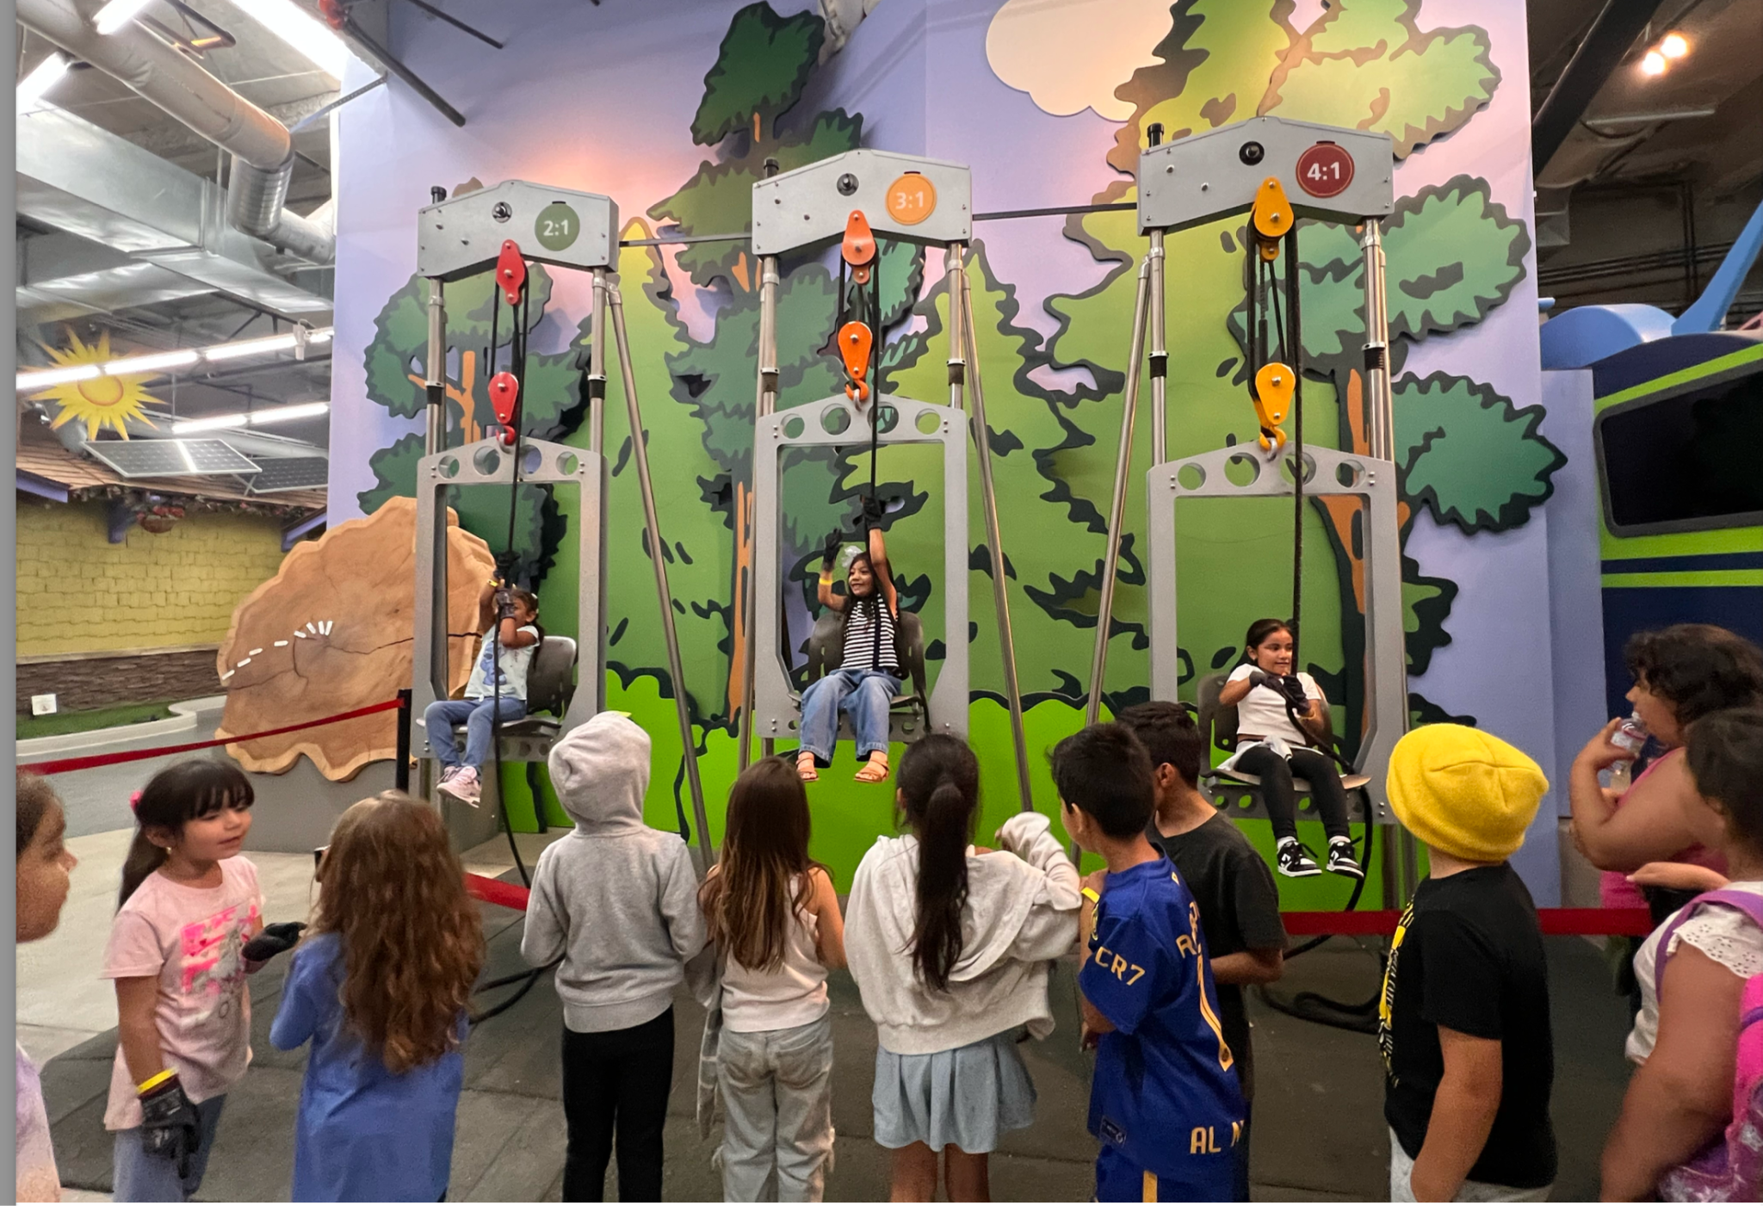
EXPANDED LEARNING PROGRAM -Beyond the Bell provides expanded learning programs for students in grades TK-12 at selected school sites for summer enrichment opportunities that provide academic engagement, physical activities, creative activities, and social-emotional learning.

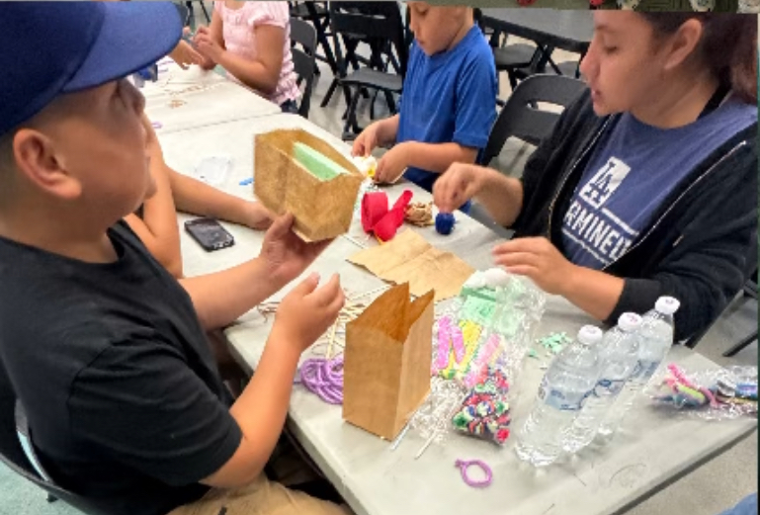
Ready Set Go students at Kingsley Elementary learned about the movie Aladin. Students participated in a group discussion about characters, setting, history, and learned fun facts about the movie Aladin. This collaborative project provided students with teamwork, cooperation and encouraged diverse ideas, while using their imagination to create a group design.

Field Trip to the Discovery Cube in Sylmar. Norwood Elementary students participating in hands-on activities at the Discovery Cube.

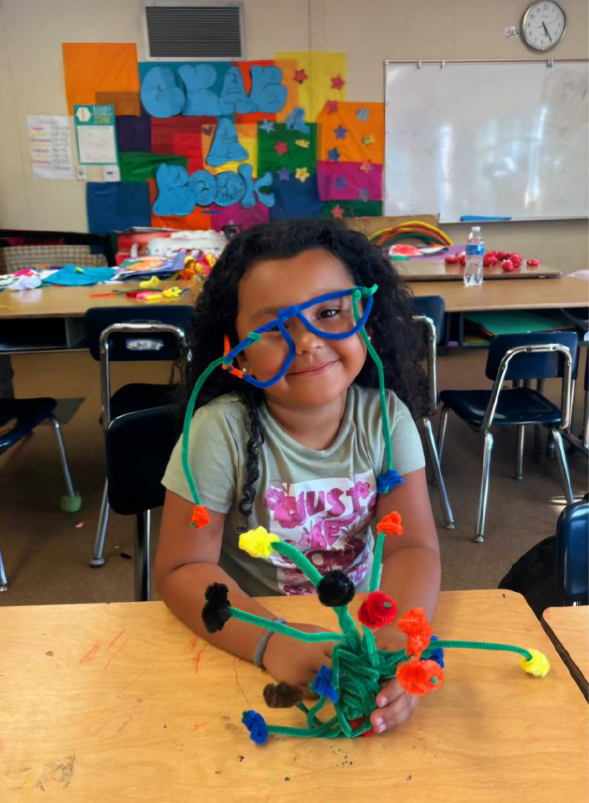
Middle School students working on Egg Drop S.T.E.A.M. activity at Camp Disney (MACES)

Youth Development Student at Barrett Elementary summer camp is showing off her creative 3D artwork
- Attendance/Students Served - 18,585

For more information, please contact Debe Loxton, Beyond the Bell Executive Director, at debe.loxton@lausd.net.

OUTDOOR AND ENVIRONMENTAL EDUCATION

At Point Fermin, located in San Pedro, California, students engage in coastal exploration and environmental studies. They participate in guided tidepooling, where they observe marine life at the Cabrillo Aquarium, learning about local ecosystems and biodiversity. Students got to splash around on the beach, swim in the pool with an ocean view and learned about the impact of human activity on marine environments. Students left fostering a sense of environmental stewardship and improved their ability to make friends.

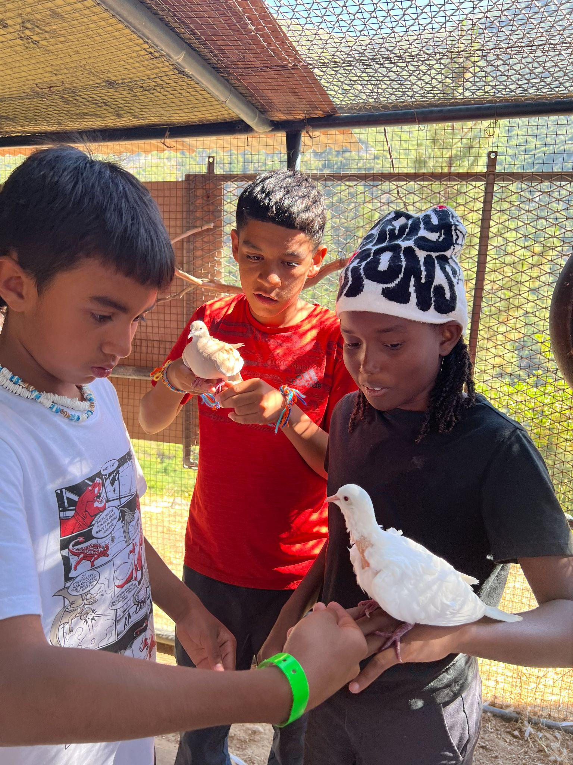
Clear Creek Outdoor Education Center, situated in the Angeles National Forest, offers a different but equally enriching experience. Here, students immerse themselves in the natural beauty of the wilderness, surrounded by forests, streams, and mountain trails. Activities at Clear Creek focus on riparian and chaparral ecosystems. Guided hikes and investigations at the creek provided an appreciation for the interconnectedness of nature. Of course, the crystal clear swimming pool was everyone’s favorite on hot summer days.

Students learn about adaptations made by living beings to live in these environments. They also study local wildlife and ecosystems through Engaged in a hands-on lesson about adaptation, students explore how doves adapt over time to become domesticated, thereby improving their chances for survival.
Attendance: 1,379 Day of Discovery, 74 Camps
For more information, please contact gerardo.salazar@lausd.net

MIGRANT EDUCATION
Migrant Education Programs continue to be highly interactive and exciting!

- 125 unique student enrollment for Migrant Education In Person (as of 7/19/24)
- 23 unique student enrollment for Migrant Education Online (as of 7/19/24)

For more information, please contact victor.gonzalez@lausd.net or follow us on Instagram and/or Facebook.
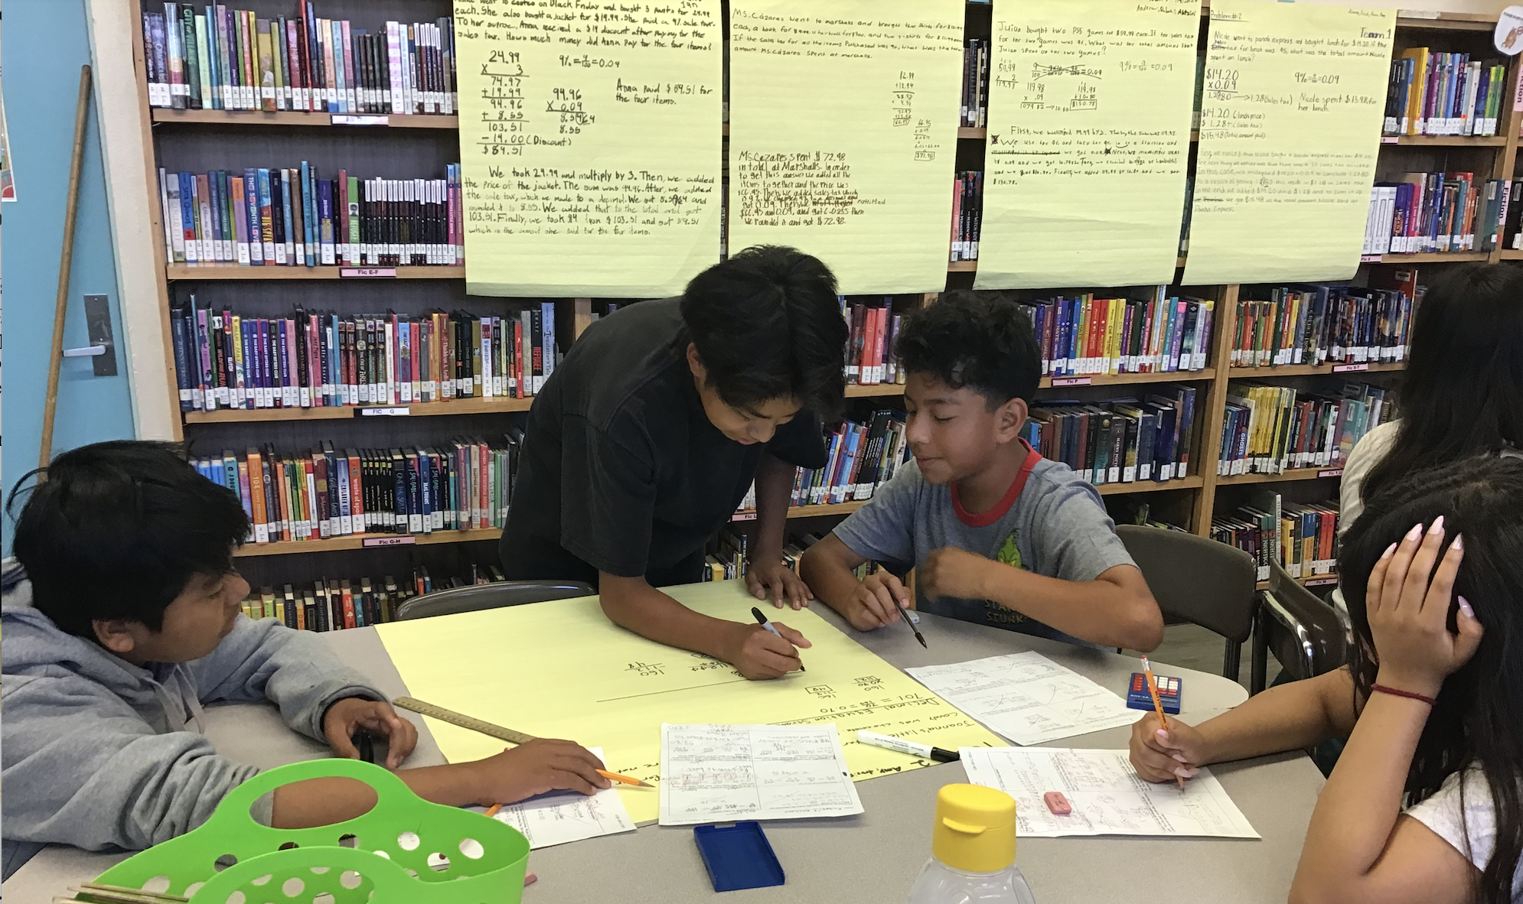
Summer for Secondary Students
Middle School - Ms. Cázares Scholars
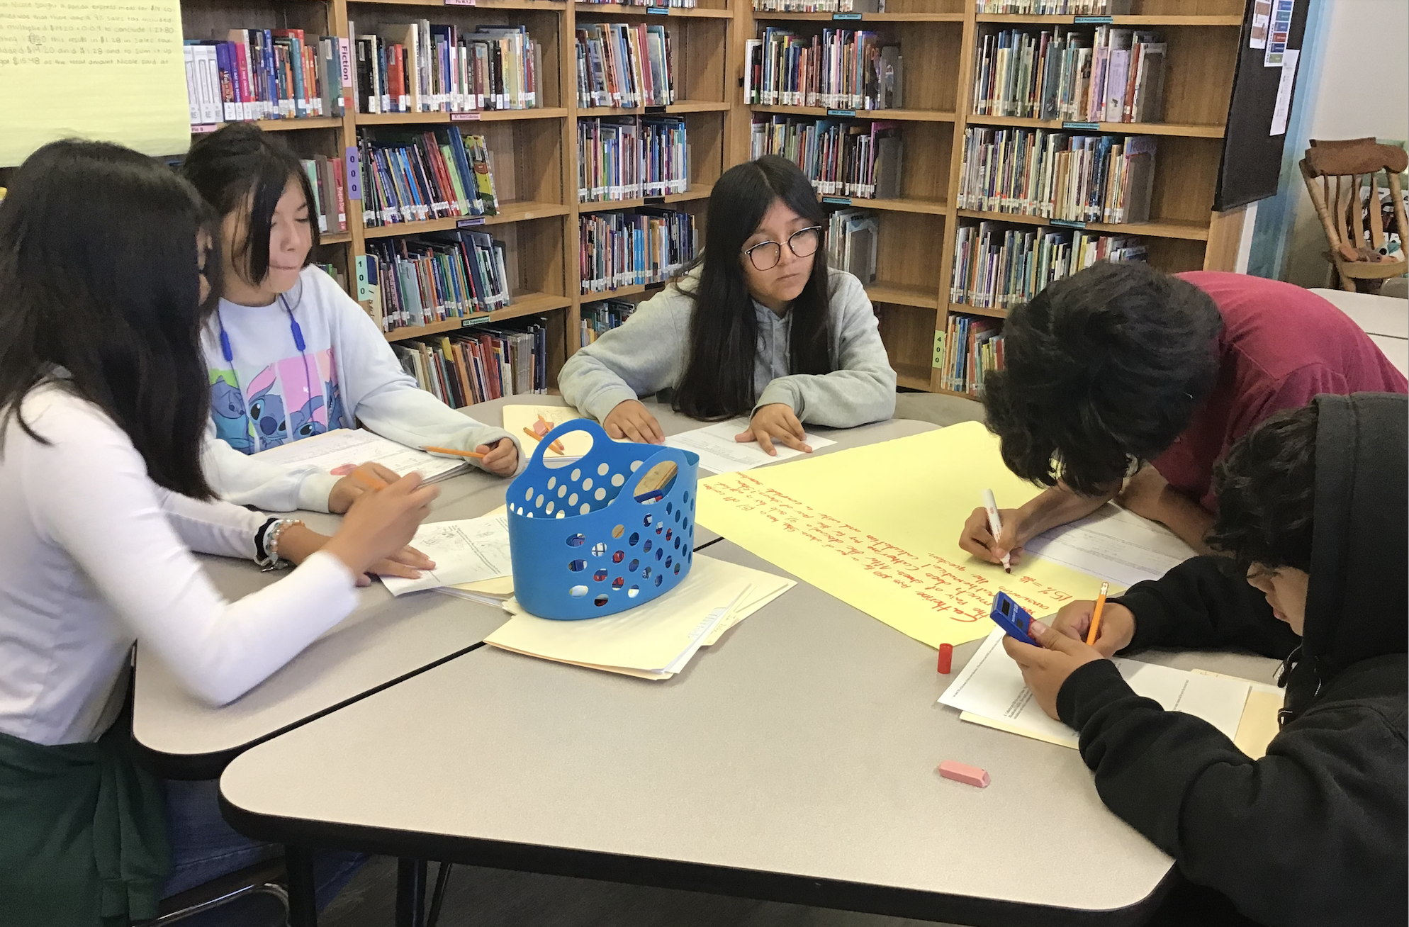
This year’s four-week 2024 summer program focuses on engaging students in problem-solving, modeling, and communicating their reasoning using mathematical language. The objective is to demonstrate the daily use of mathematics. For example, we encounter ratios and proportional relationships while shopping, such as during Black Friday sales or Amazon Prime Day deals. Discussions on tips, sales tax, and discounts help contextualize these concepts, making them less intimidating. Today's snapshot shows incoming sixth, seventh, and eighth-grade students working together to solve multistep ratio and percent problems related to simple interest and markdowns. One sample problem they solved is: Catherine buys a pair of shoes for $80 with a 15% off coupon. After the discount, a 9% sales tax is applied. How much does Catherine pay? Students used strategies like double number lines, percent proportion equations, and decimal equations to find the solution and explain their reasoning.
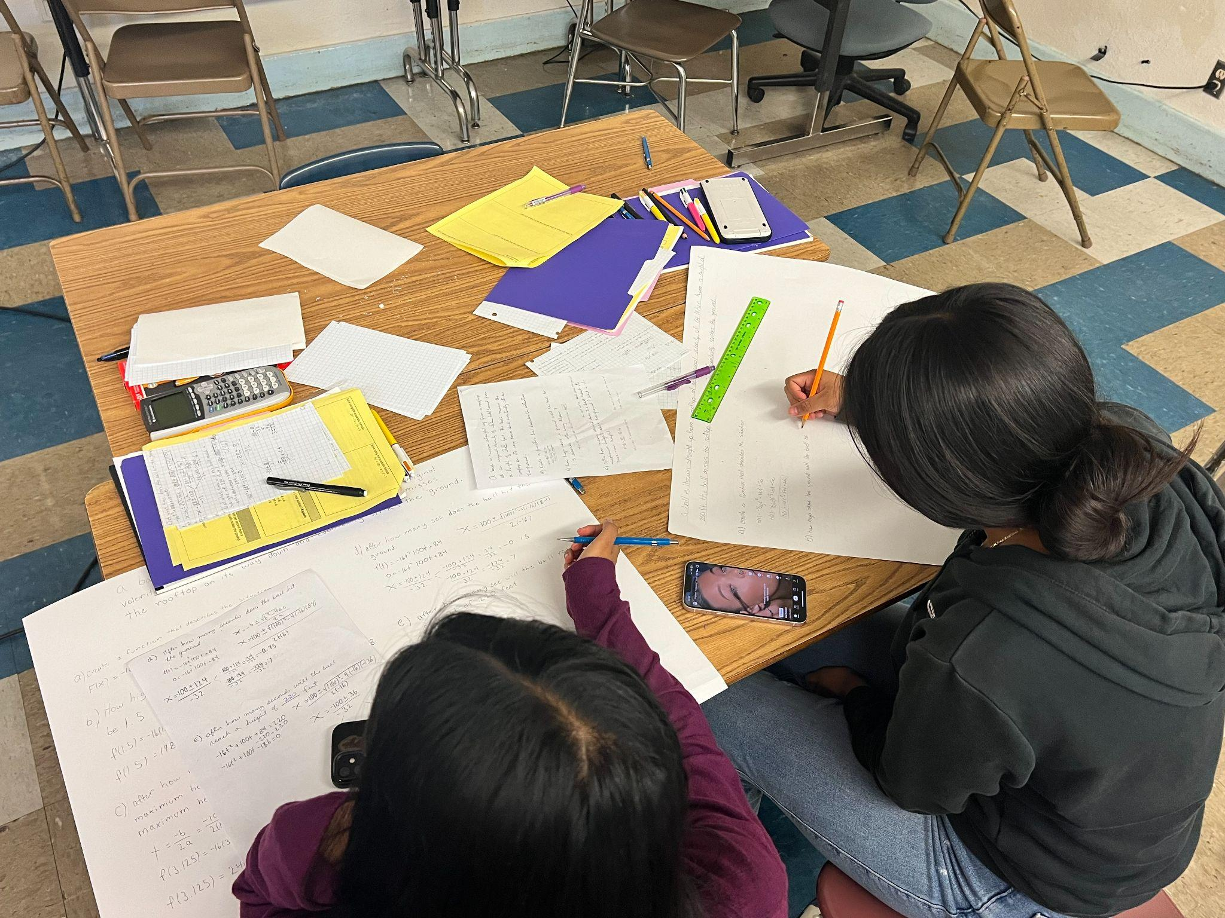
High School - Mr. Varela
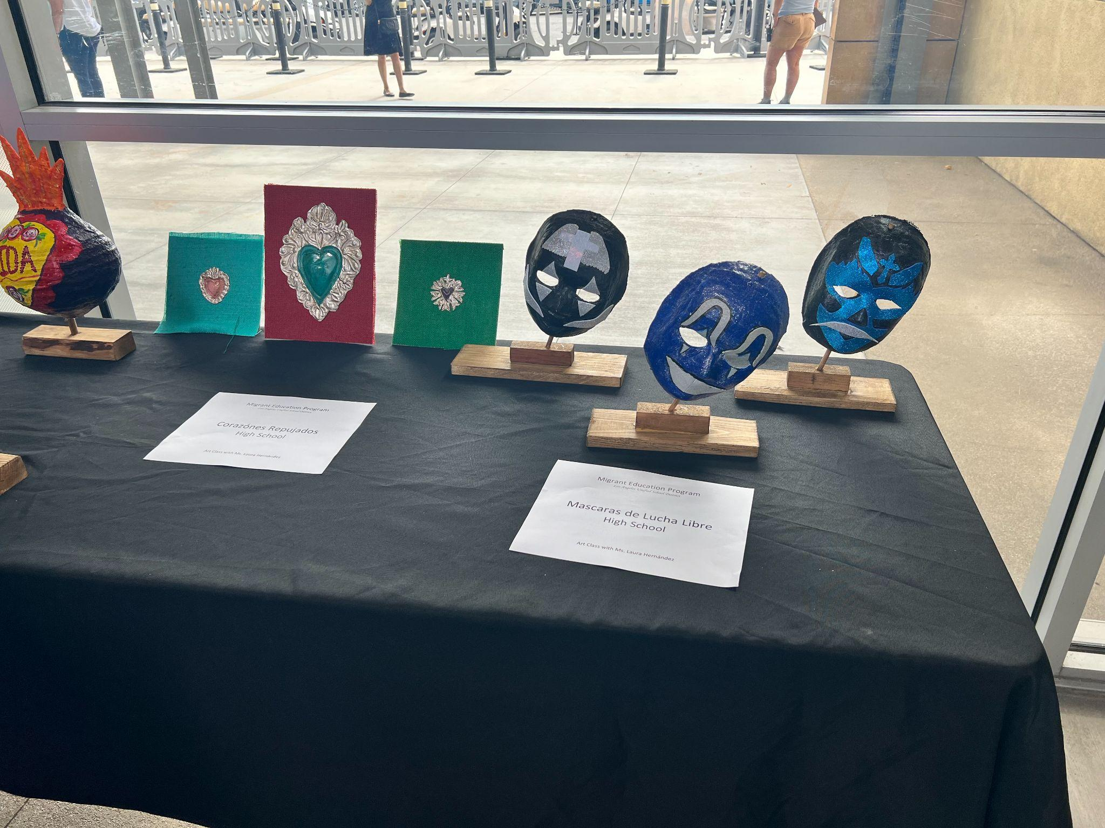
We started with graphing quadratic functions on Desmos.com and identifying key features such, vertex, roots, x and y intercepts, maximum/minimum values and line of symmetry. We then move onto using algebraic strategies such as vertex formula, factoring, quadratic formula and completing the square to find vertex, roots, zeros, x and y intercepts. Each student was given a projectile motion concept task in which a ball is thrown straight up in the air from a rooftop given an initial velocity and an initial height they are to create a quadratic function describing the situation and using what they had previously learned to find maximum height, how long before the ball hit the grown and other questions pertaining to the task at hand. Pictures below show scholars working on their concept tasks and creating a poster to present to parents at an open house. Students also took an art class and the last picture on the right shows of their artistic creativity.
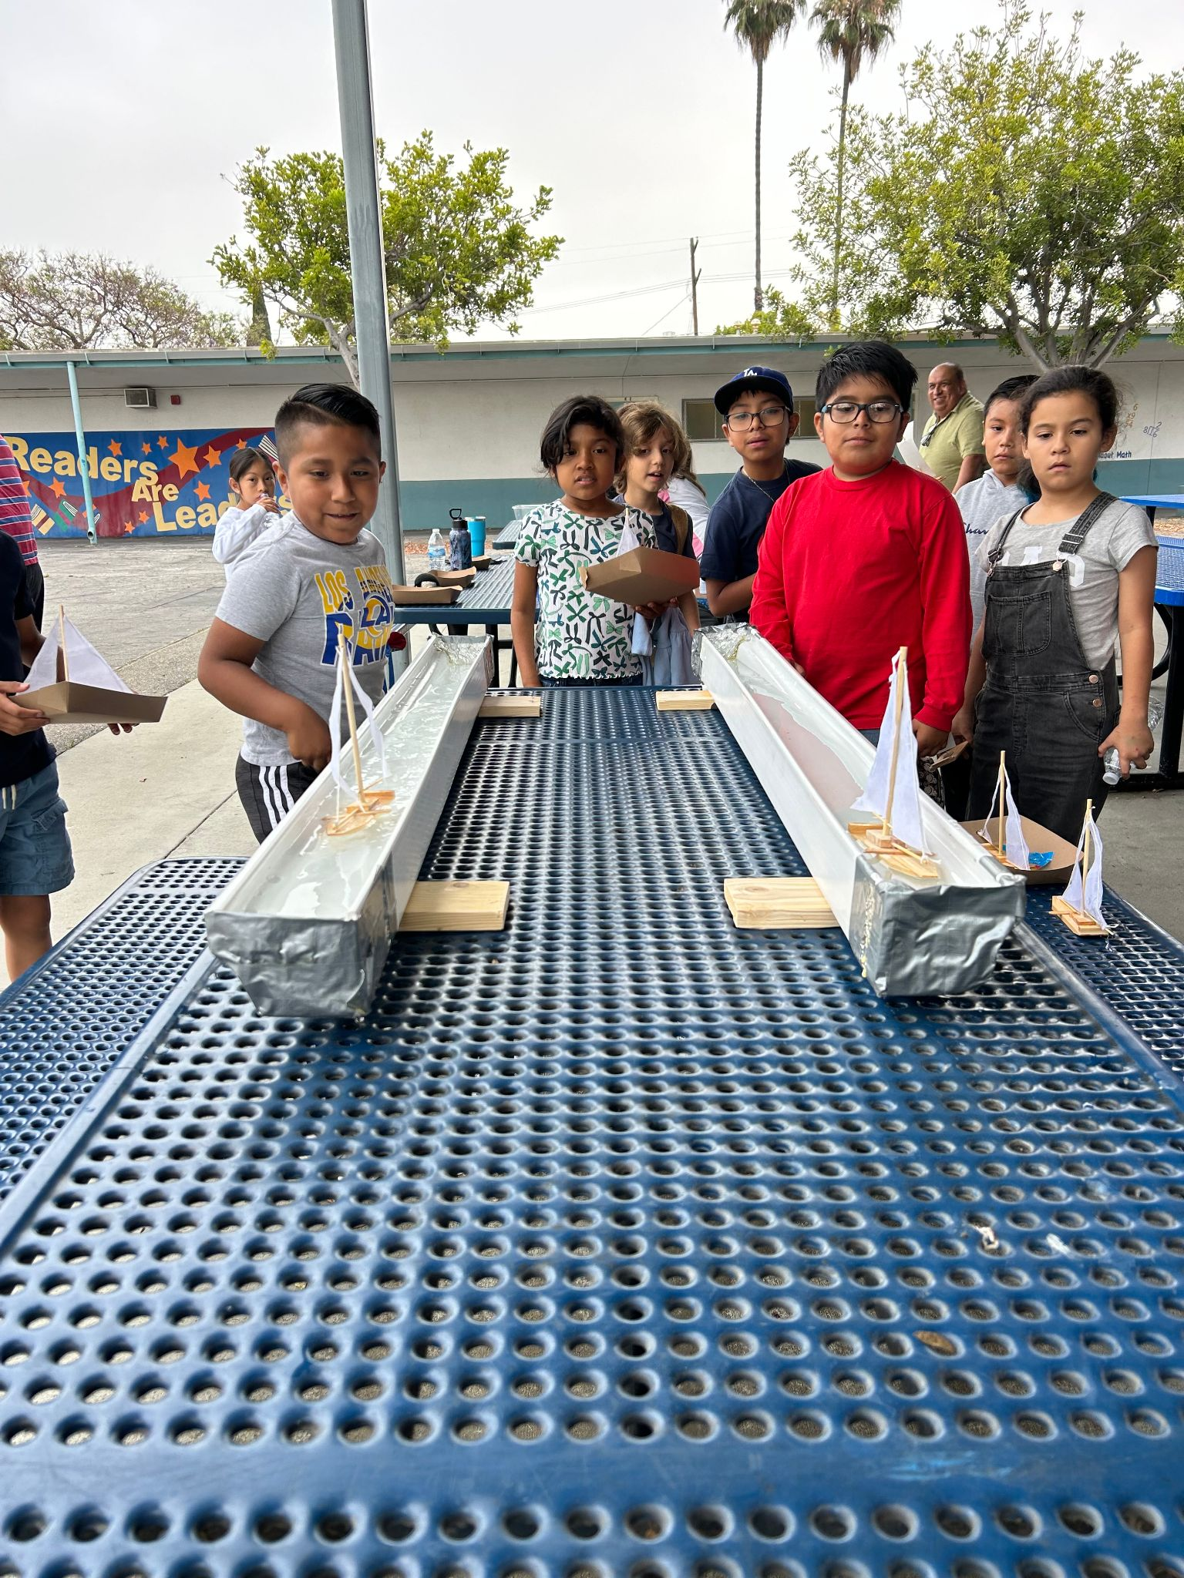
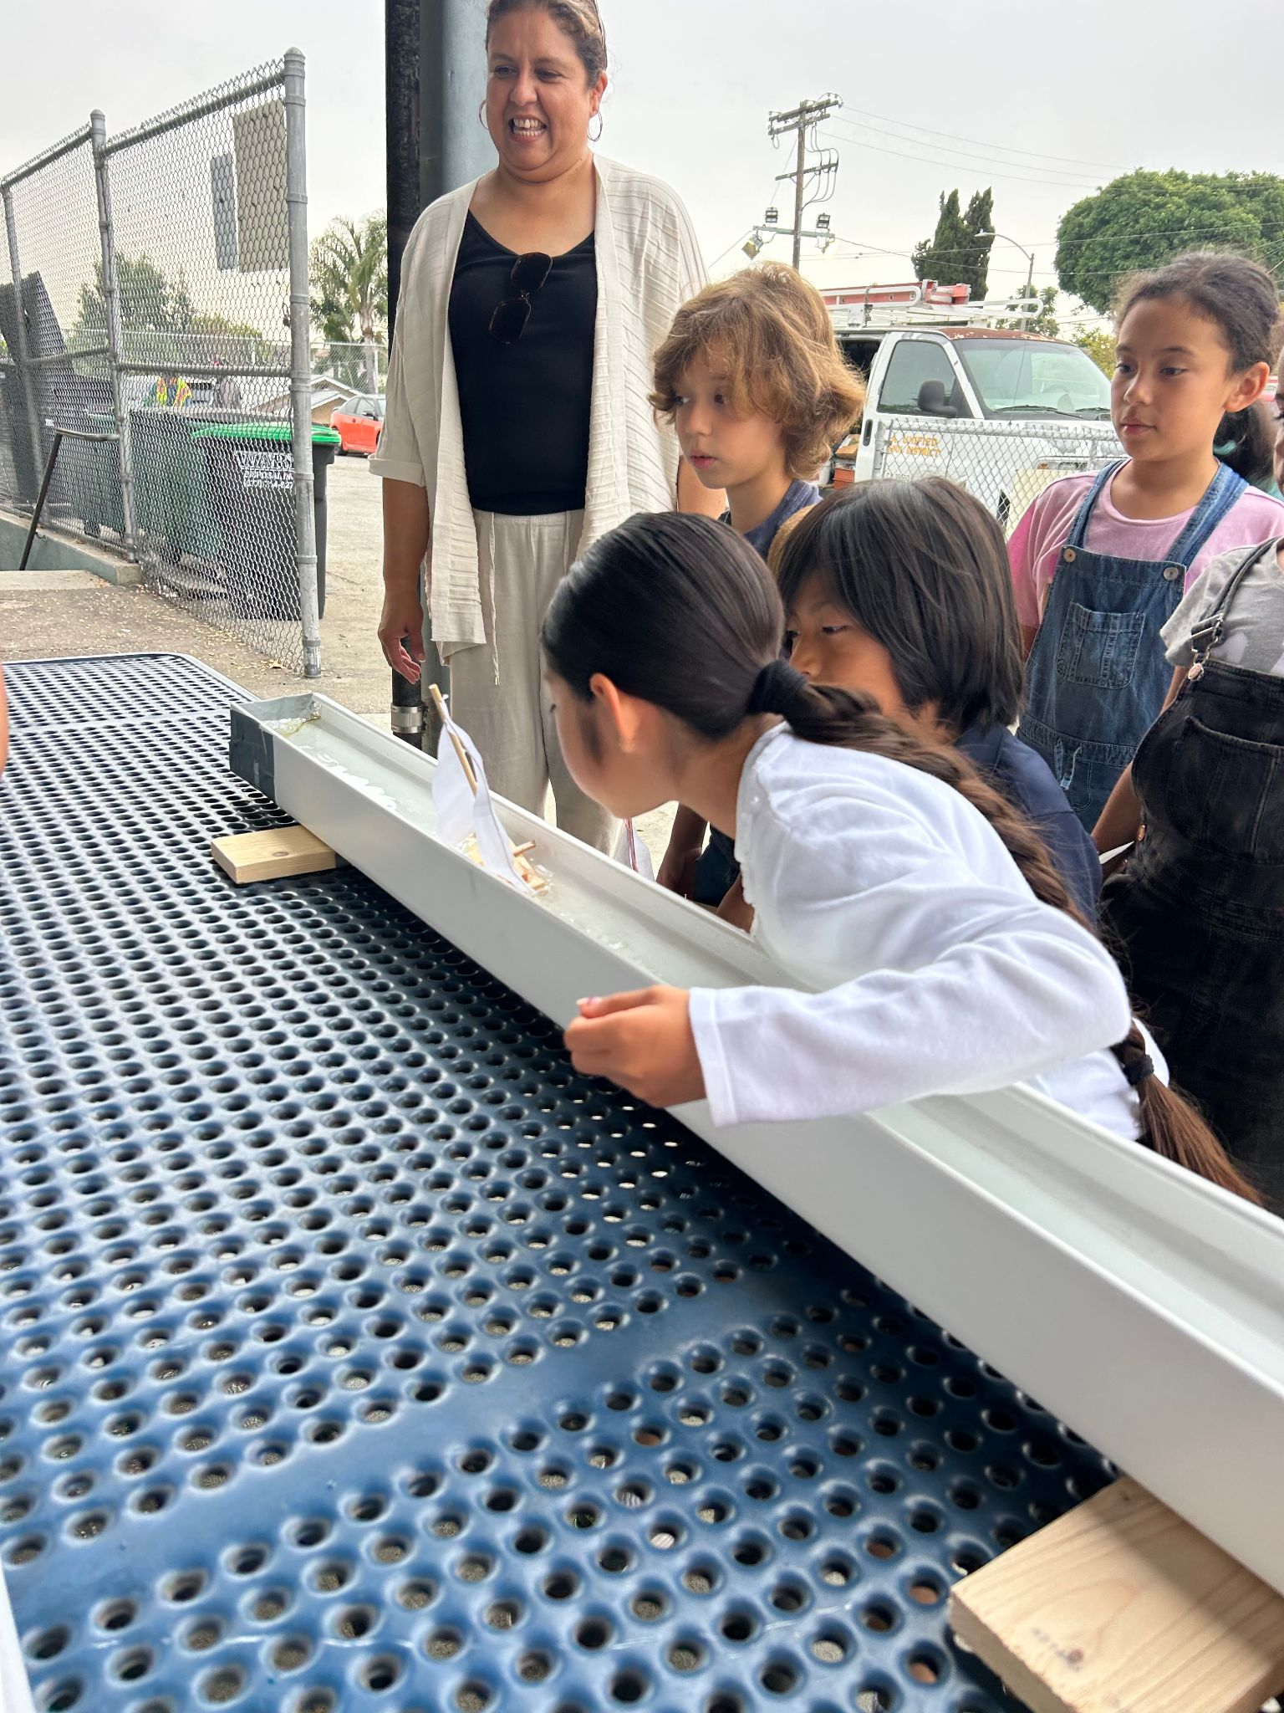
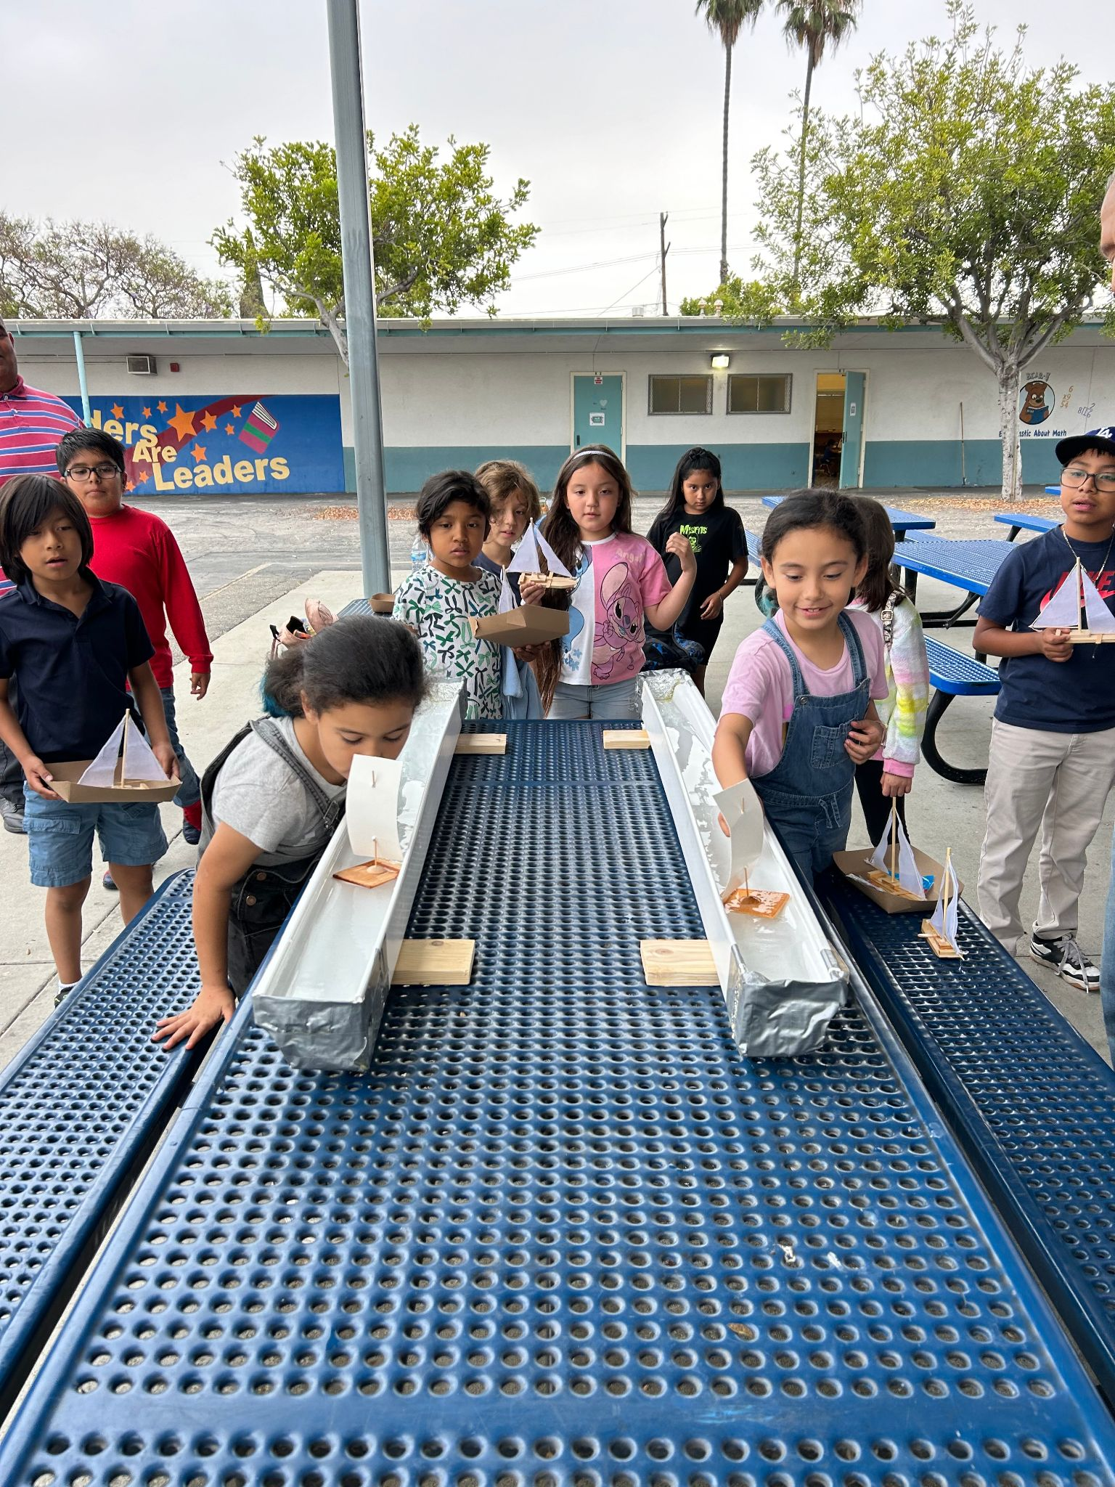
MEP Regatta
Summer School students racing boats as part of Mr. Serino's science class. The students learn about how important it is for the flow of wind and air based on Bernoulli's Principle.

LA Zoo Family Day
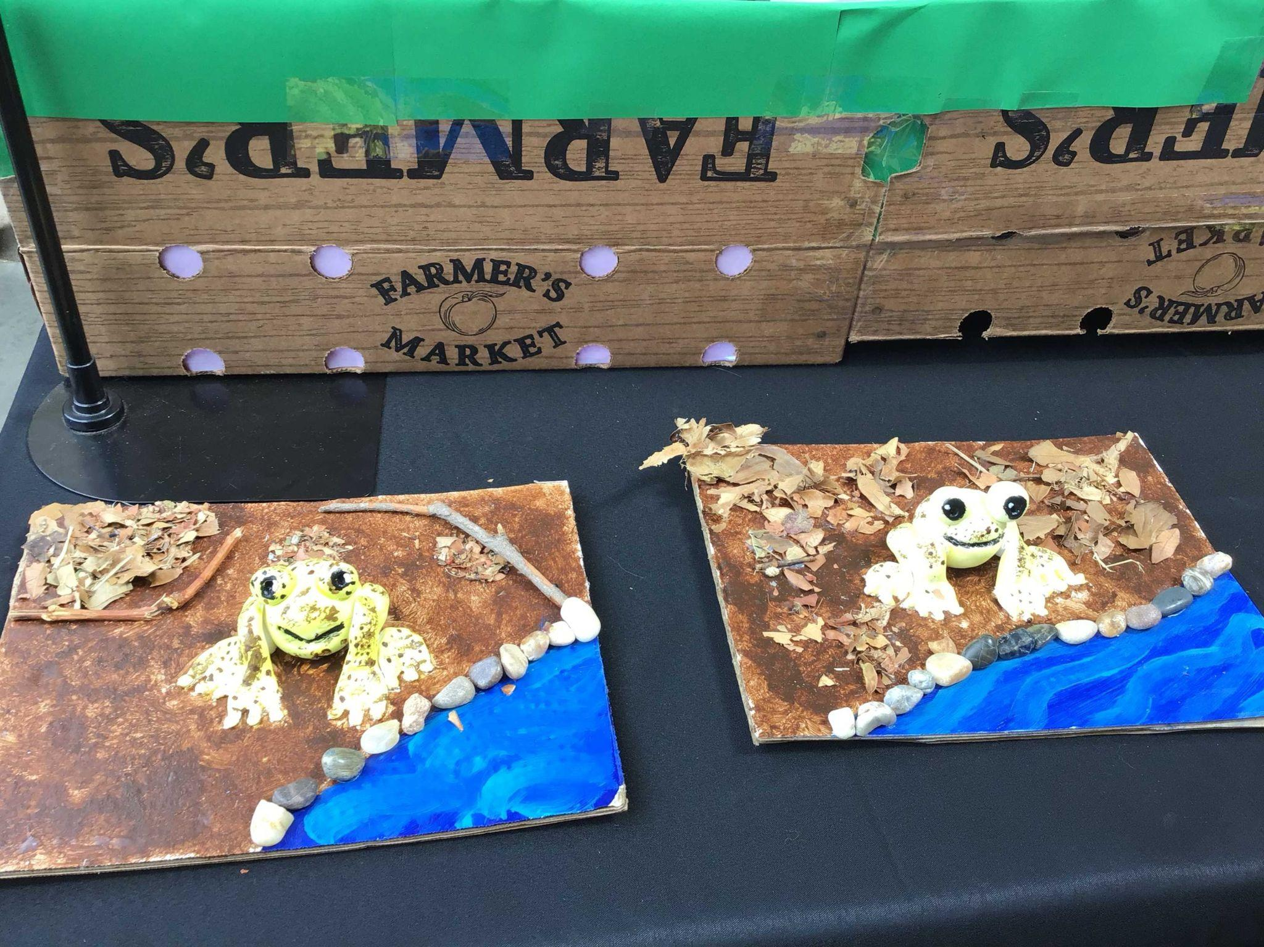
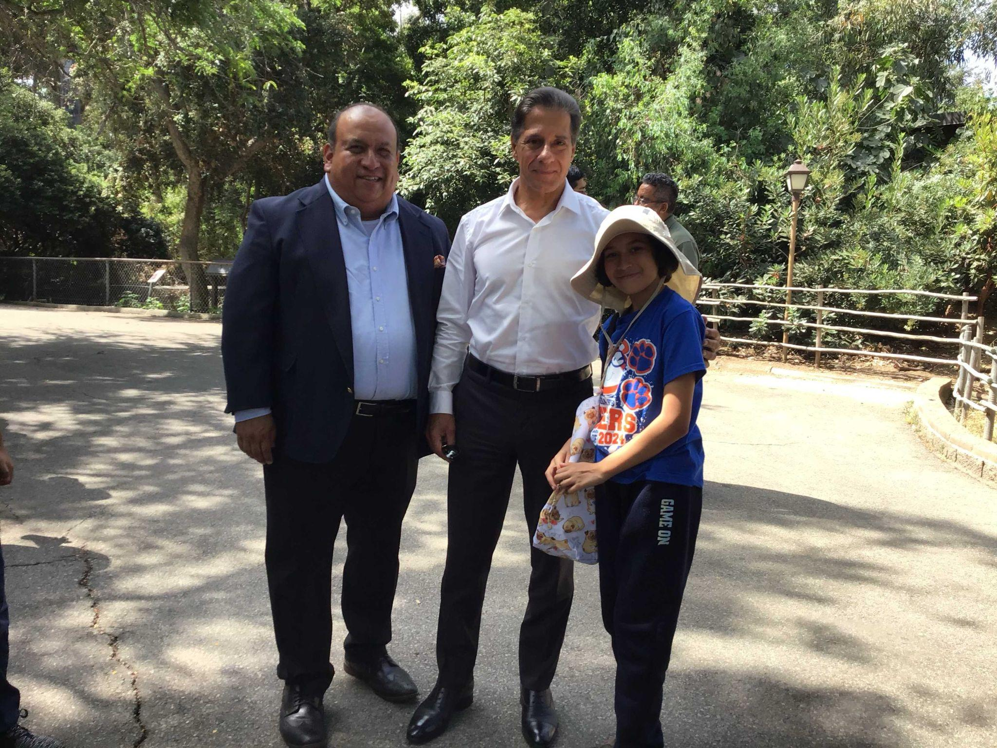
The 2024 culmination of collaboration with the LA Zoo had students displaying their research, artwork, and providing oral presentations of what they learned working with the LA Zoo staff. In attendance was Superintendent Carvalho, news media, parents of students, and all other migrant students who participated in our summer programming.

ARTS EDUCATION BRANCH
Elementary School
35 Arts teachers in dance, music, theater and visual art supported 151 UTK-5 and ESY schools and over 11,700+ students each week! Please enjoy the pictures below of some examples of our amazing summer dancers, artists, actors and musicians.
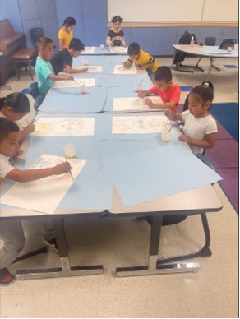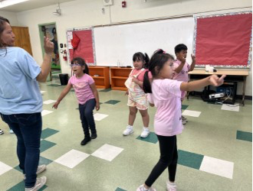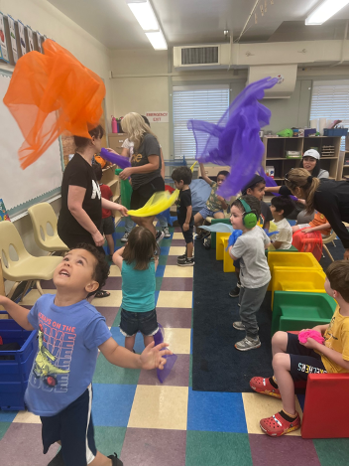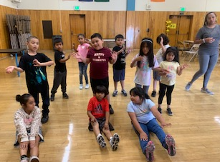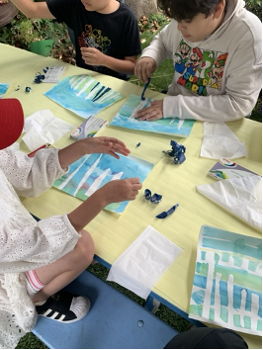

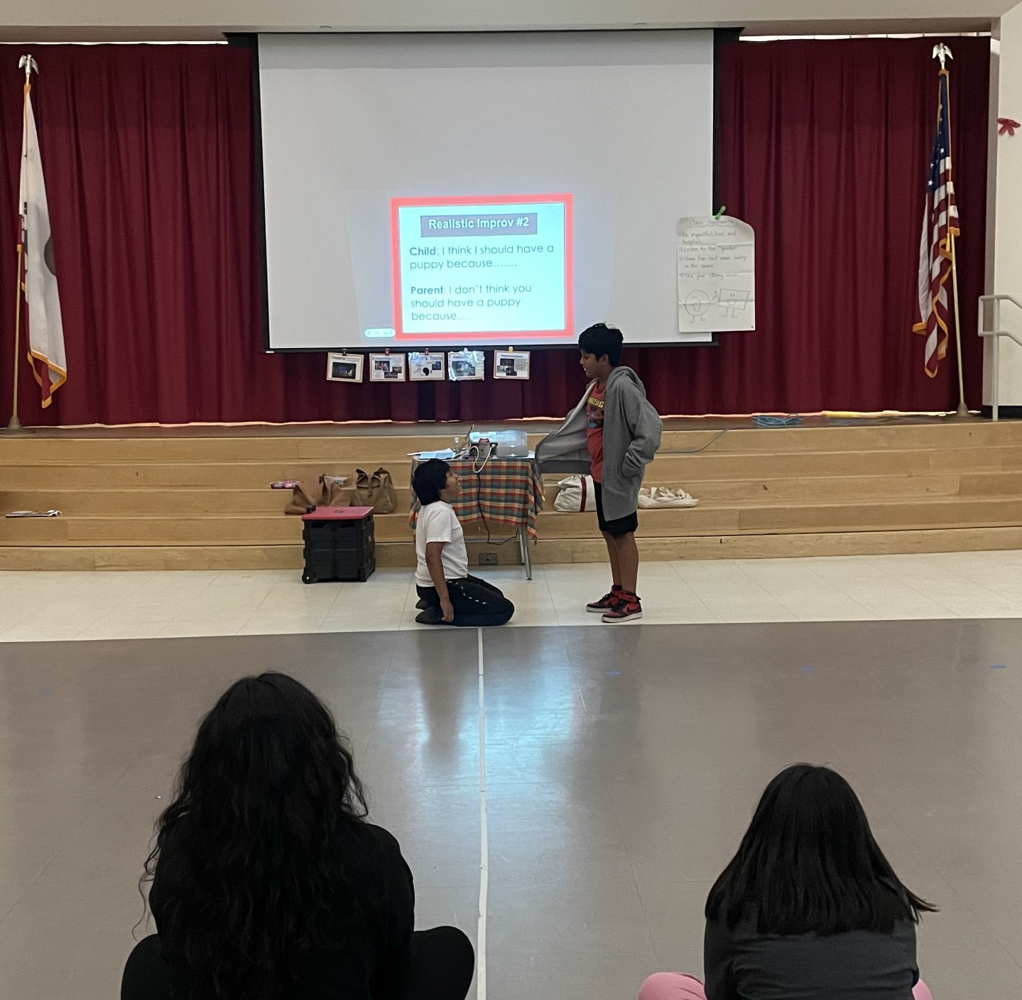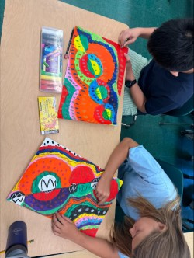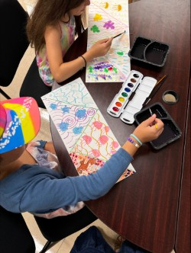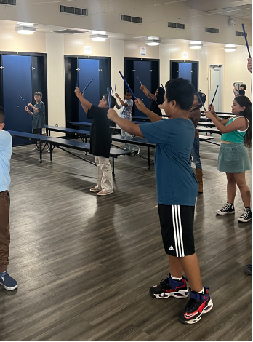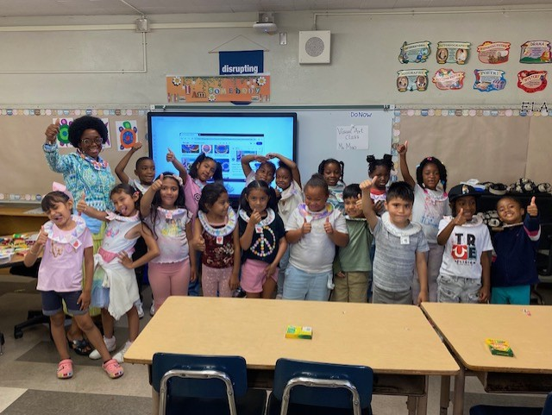

Middle School
17 Arts Community Network (ACN) partners provided arts services twice weekly to 74 school middle school and ESY sites! Some of the highlights expressed by our partner teaching artists are found below.
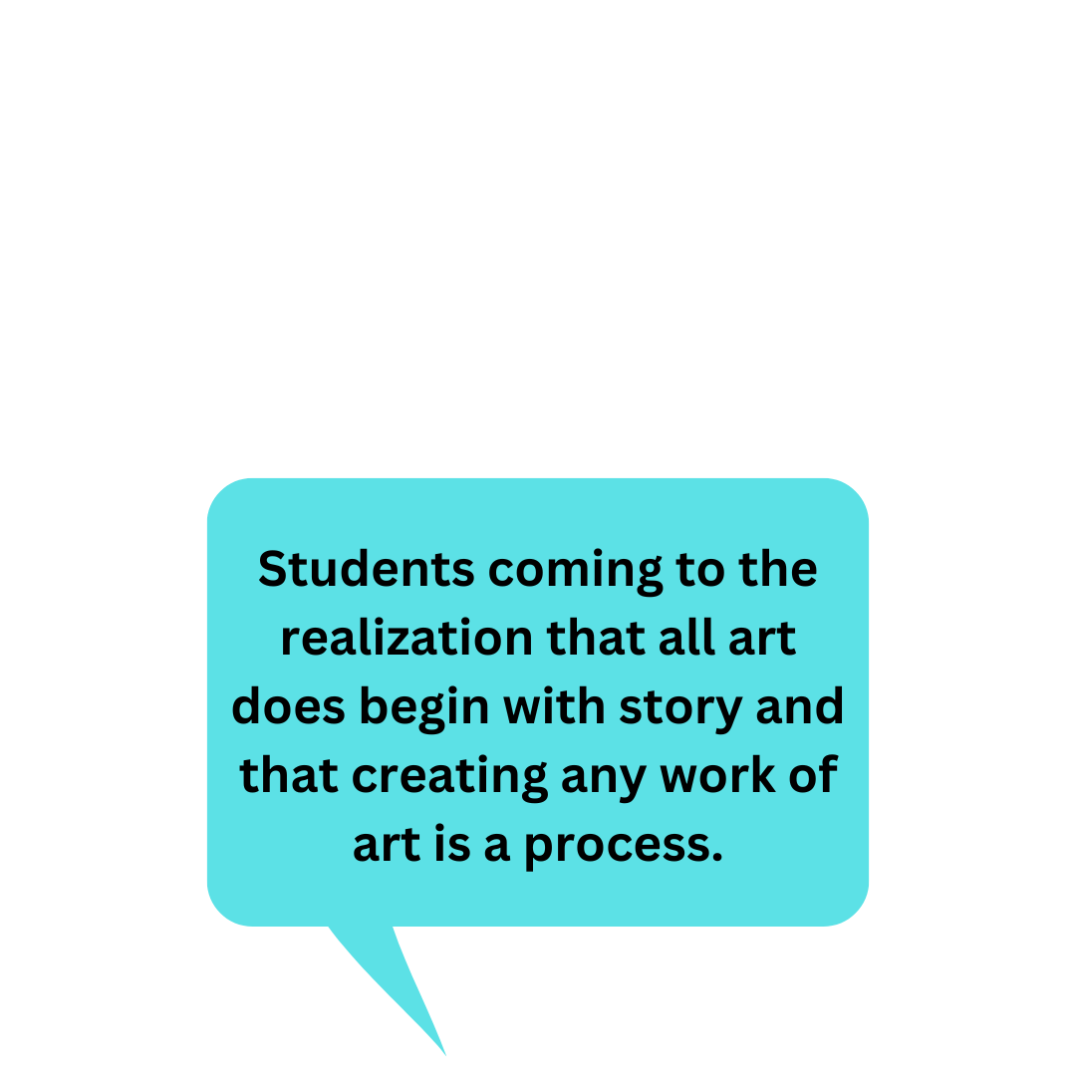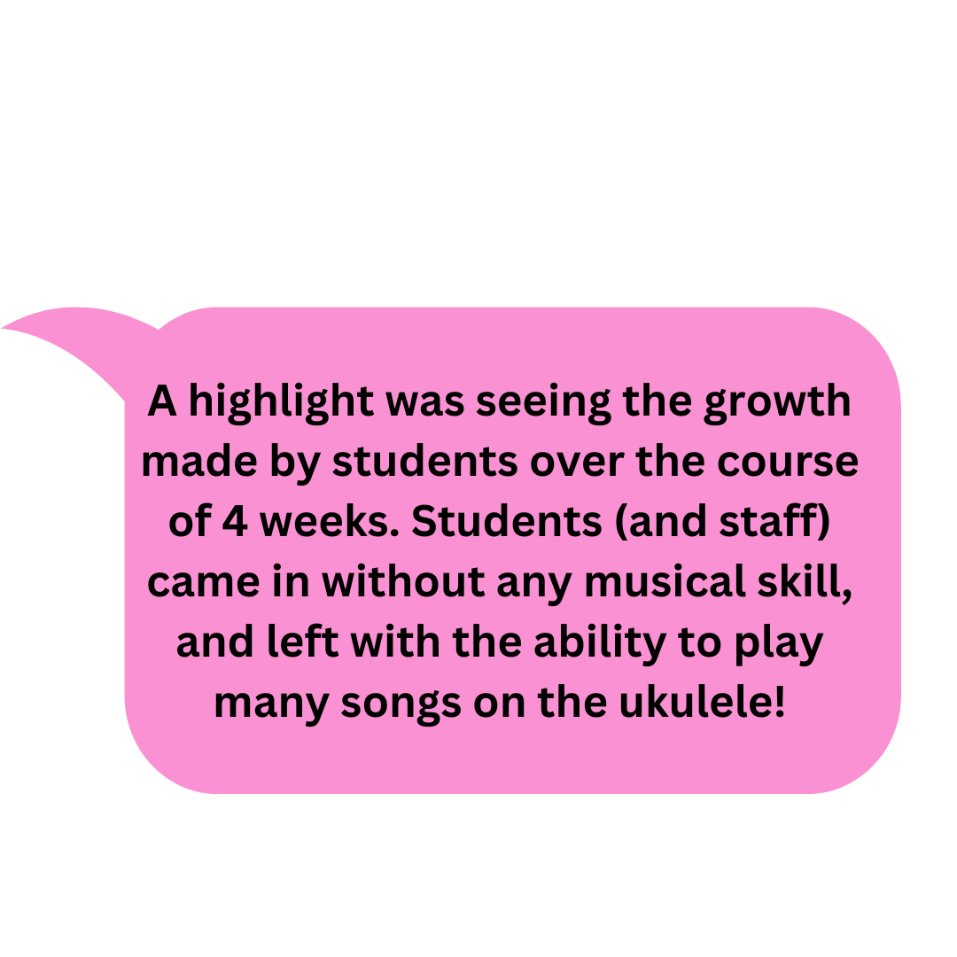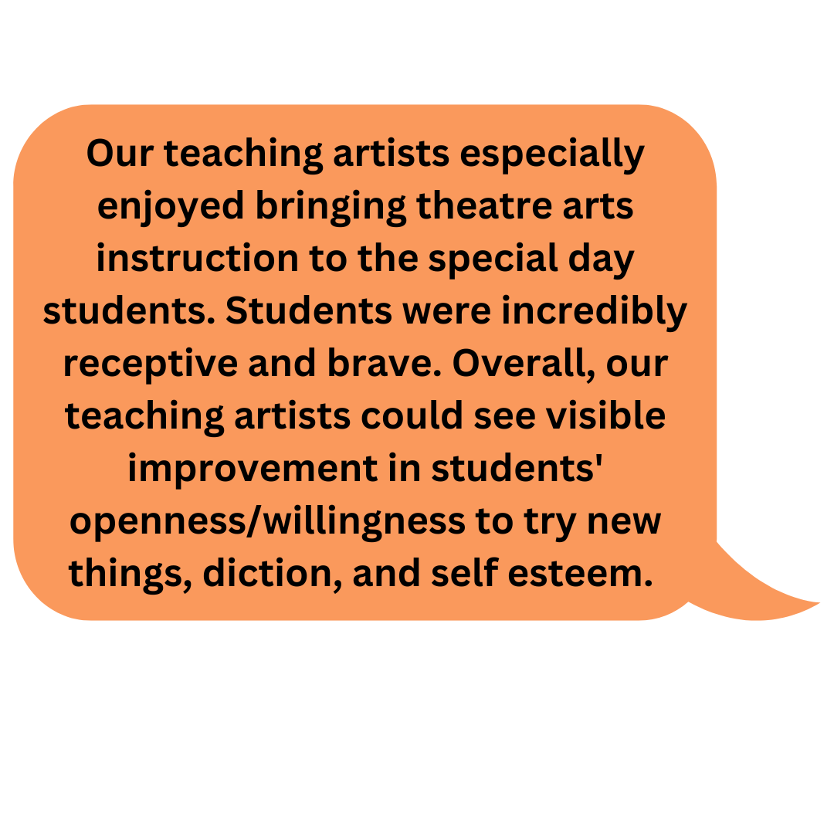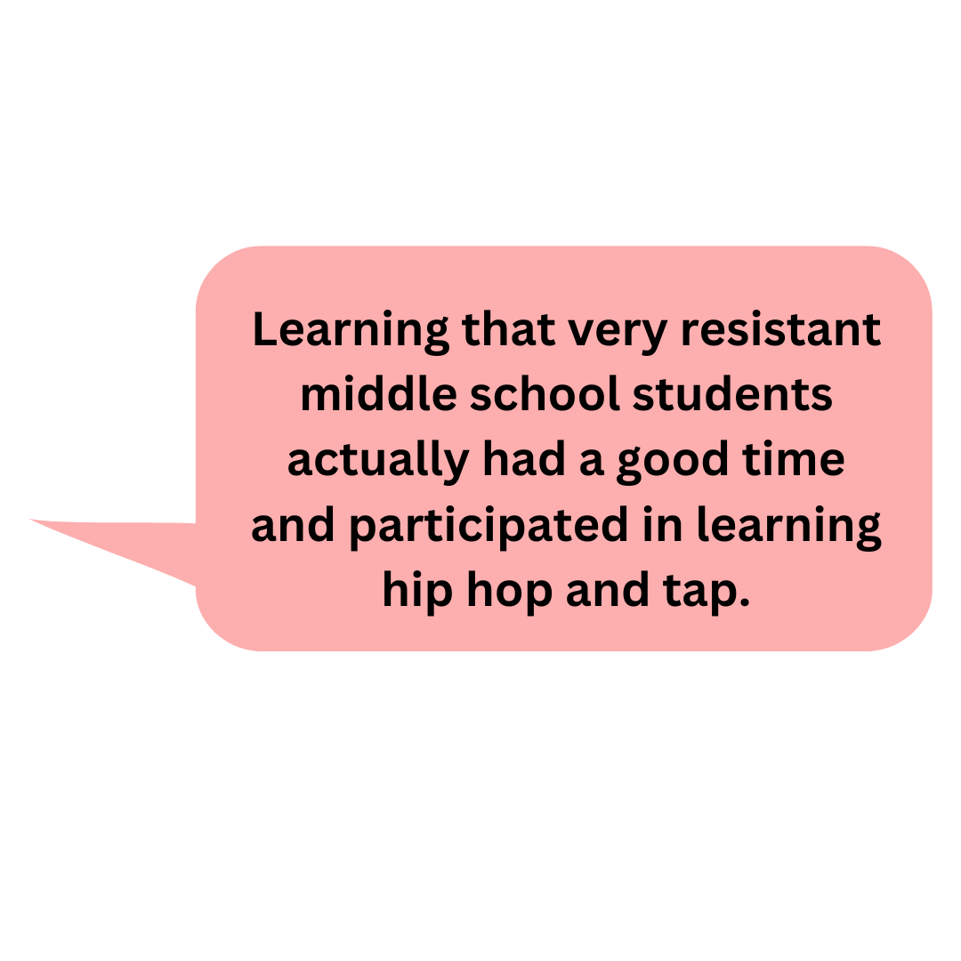
Virtual Enrichment
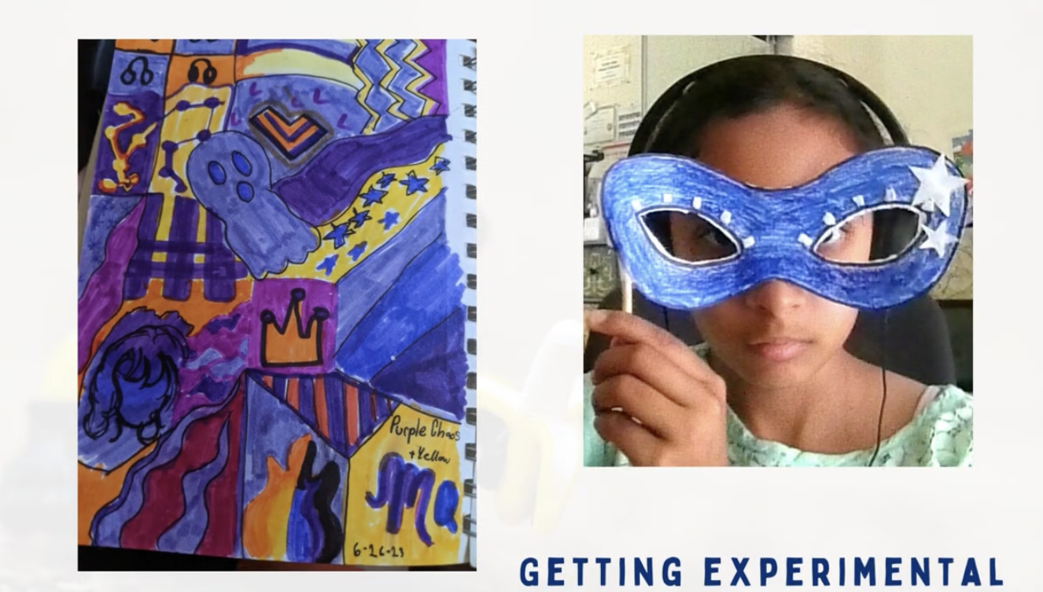
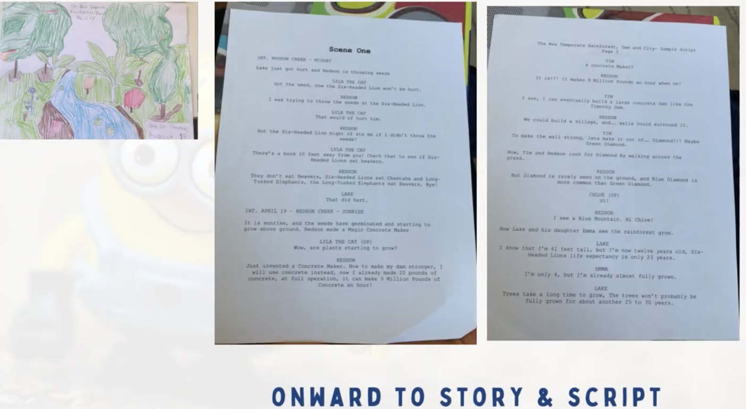
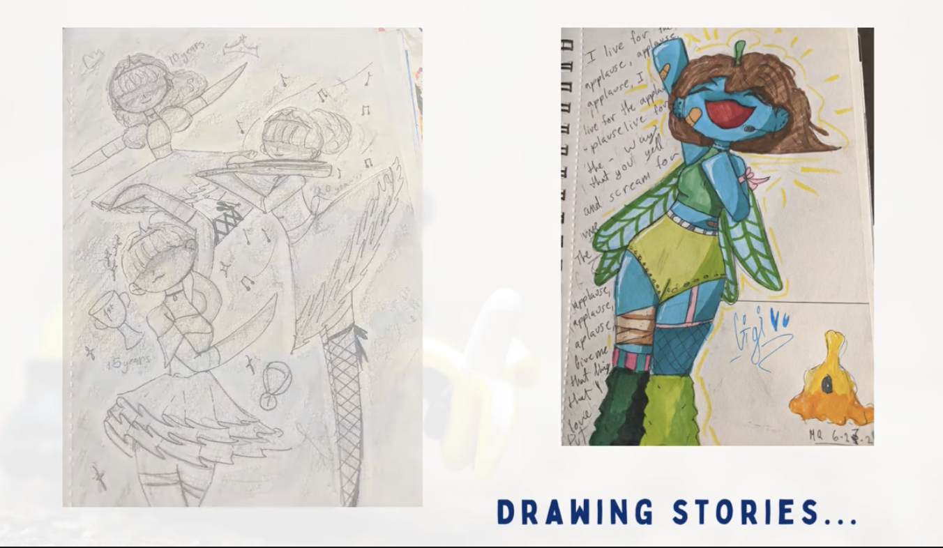

The Arts Education Branch offered 26 virtual enrichment class sessions to 1256 students in animation, dance, music, theater and visual art as well as specialized instrumental classes in acoustic guitar, electric guitar, electric bass, and ukulele.


Animation with Illumination Summer 2024 Video

For more information, please contact Jessica Williams, Administrative Coordinator, K-12 Arts, at jessica.w.williams@lausd.net.

A-G SUMMER TRANSITION SUPPORT HUBS
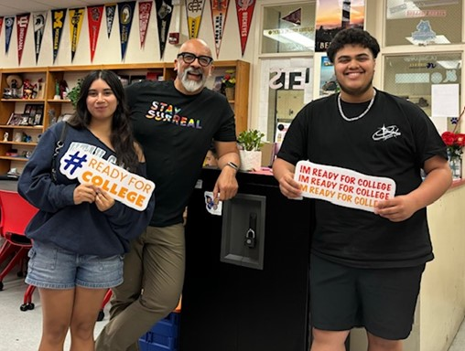
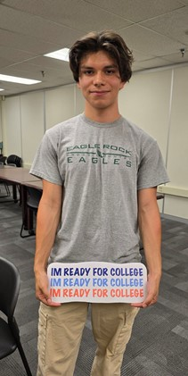
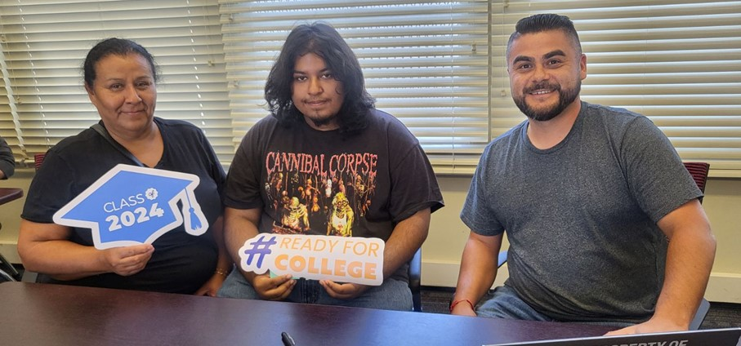
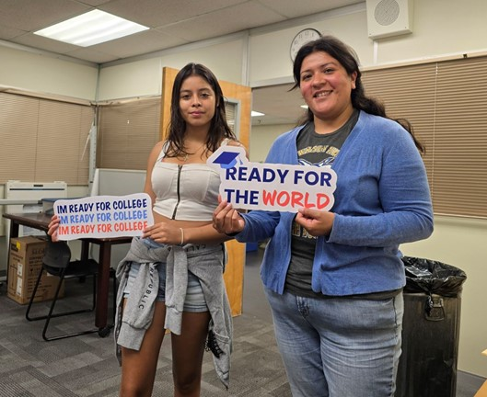
The Hubs regular hours were expanded this past week to meet a high level of demand. With the July 15 deadline for CSUs and UCs to receive final transcripts, A-G staff and our amazing Summer Hubs school counselors provided additional support on Friday July 12 and Monday July 15 from 9am-2pm on Zoom. In these two days, almost 800 students received individual consultation to resolve challenges and meet the deadline. As well as working with 4-year bound students, Hubs are now chiefly outreaching students heading to community colleges. As we head into the final week of Summer Hubs, the focus will be connecting with students who have not yet submitted a financial aid application. Staff will work with these students to get their applications completed and connect them with postsecondary options.

At the GEAR UP FOR LA sites, the intensive college transition work continues. Through July 12, almost 400 grads came in for personal help, and over 34,000 communications were sent and received.

Districtwide, this summer has been an outstanding experience supporting Class of ‘24 grads to their chosen colleges, and we thank all the counselors and staff who dedicated their time for this initiative!

CTE-LINKED LEARNING

Summer Internships
This summer 338 students are interning across the city of Los Angeles. Their placements include offices at Beaudry, regional offices, KLCS, Orthopedic Institute for Children, LA’s Best, Beyond the Bell sites, and other partner sites (view the full list of worksites here).

Students from the Academies of Education and Empowerment at Carson Complex are currently interning for Beyond the Bell at Carson St. Elementary. Not only are these students earning money over the summer, but they are doing work that aligns with the career pathway they are enrolled in.

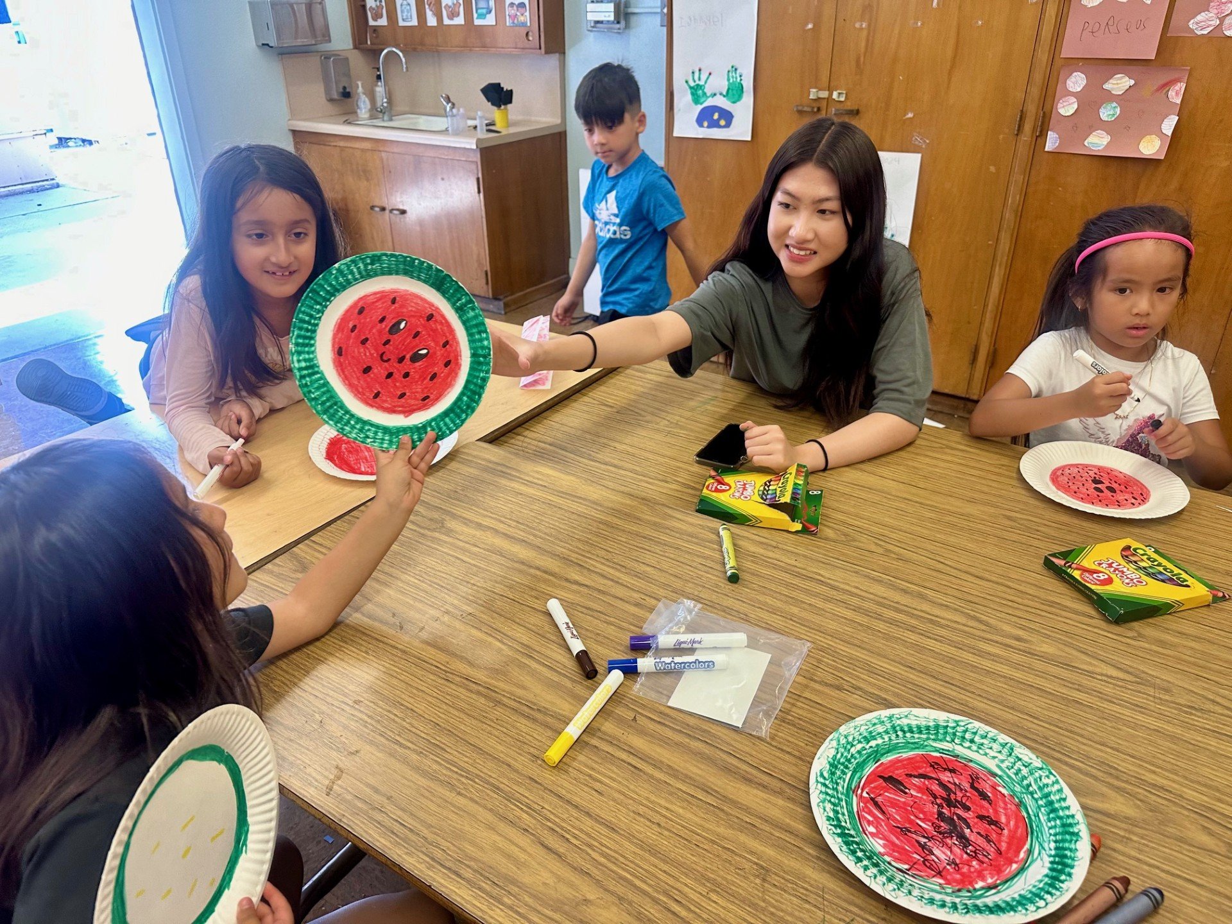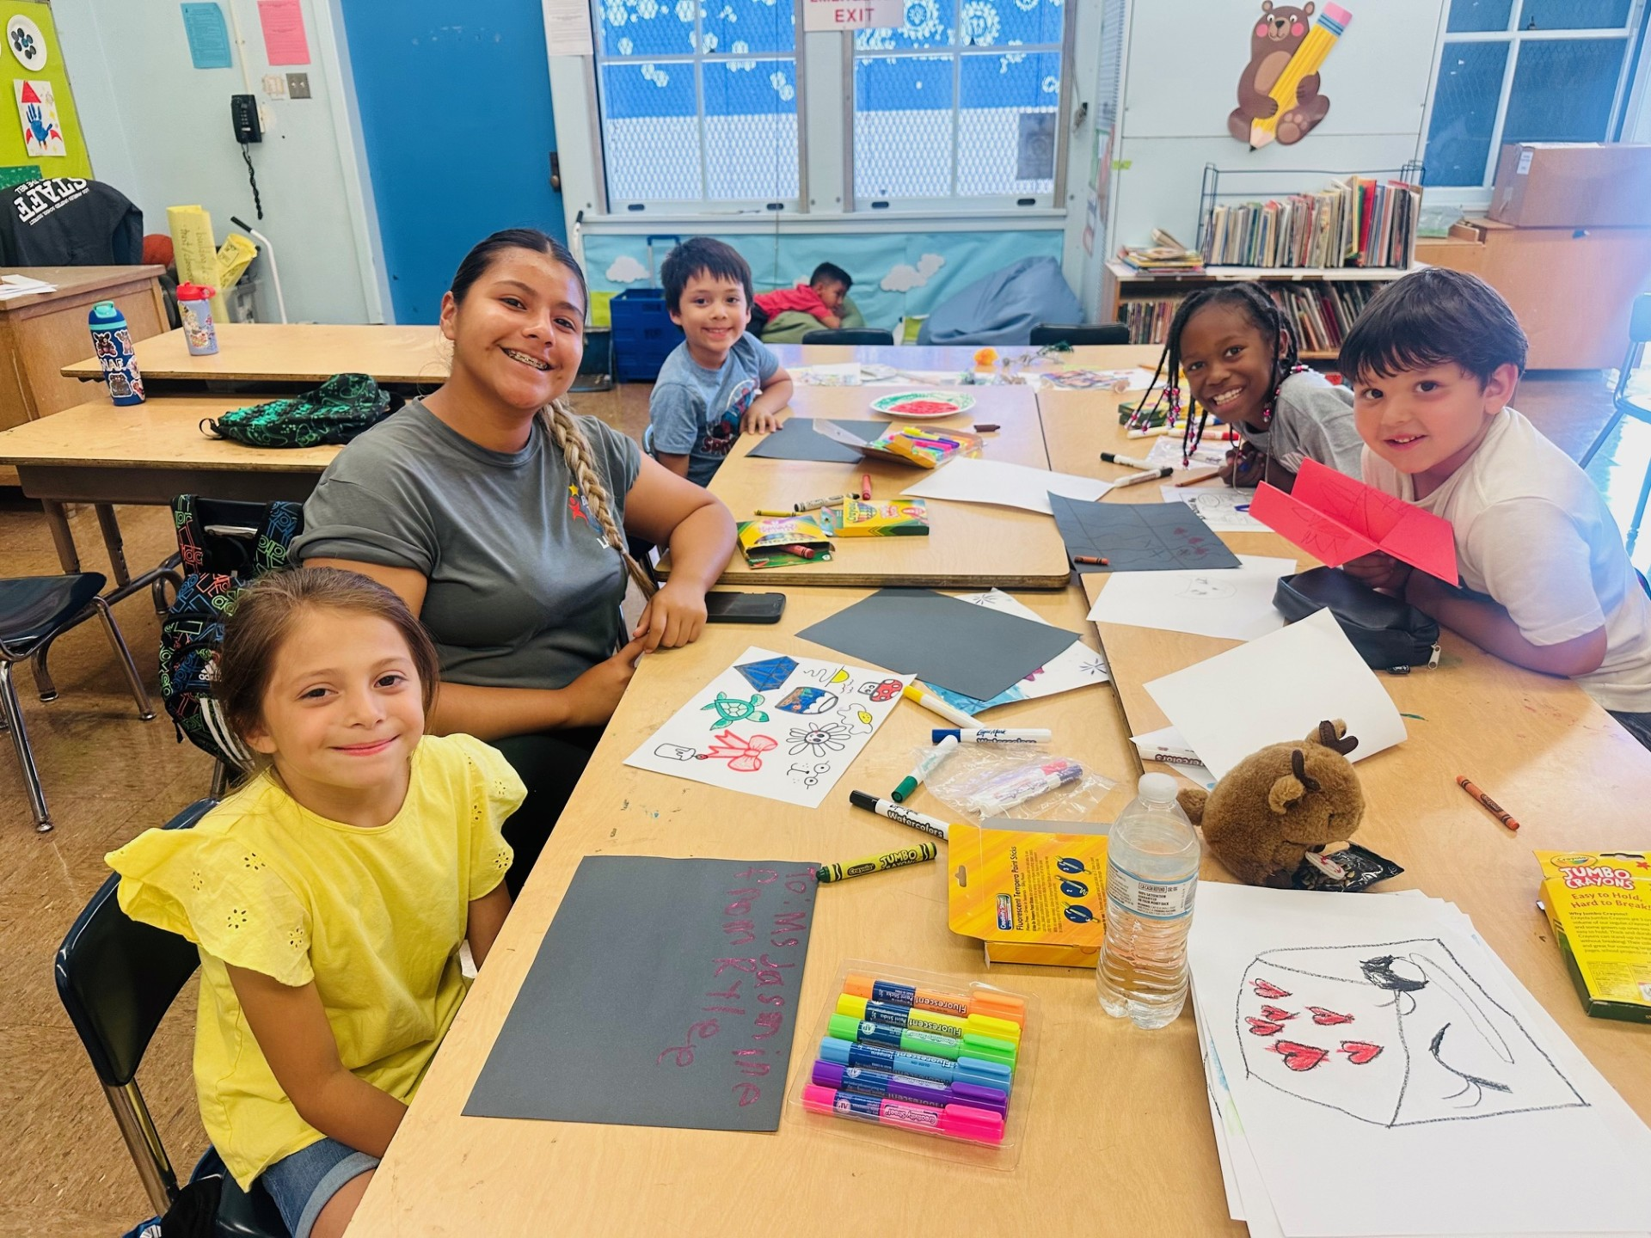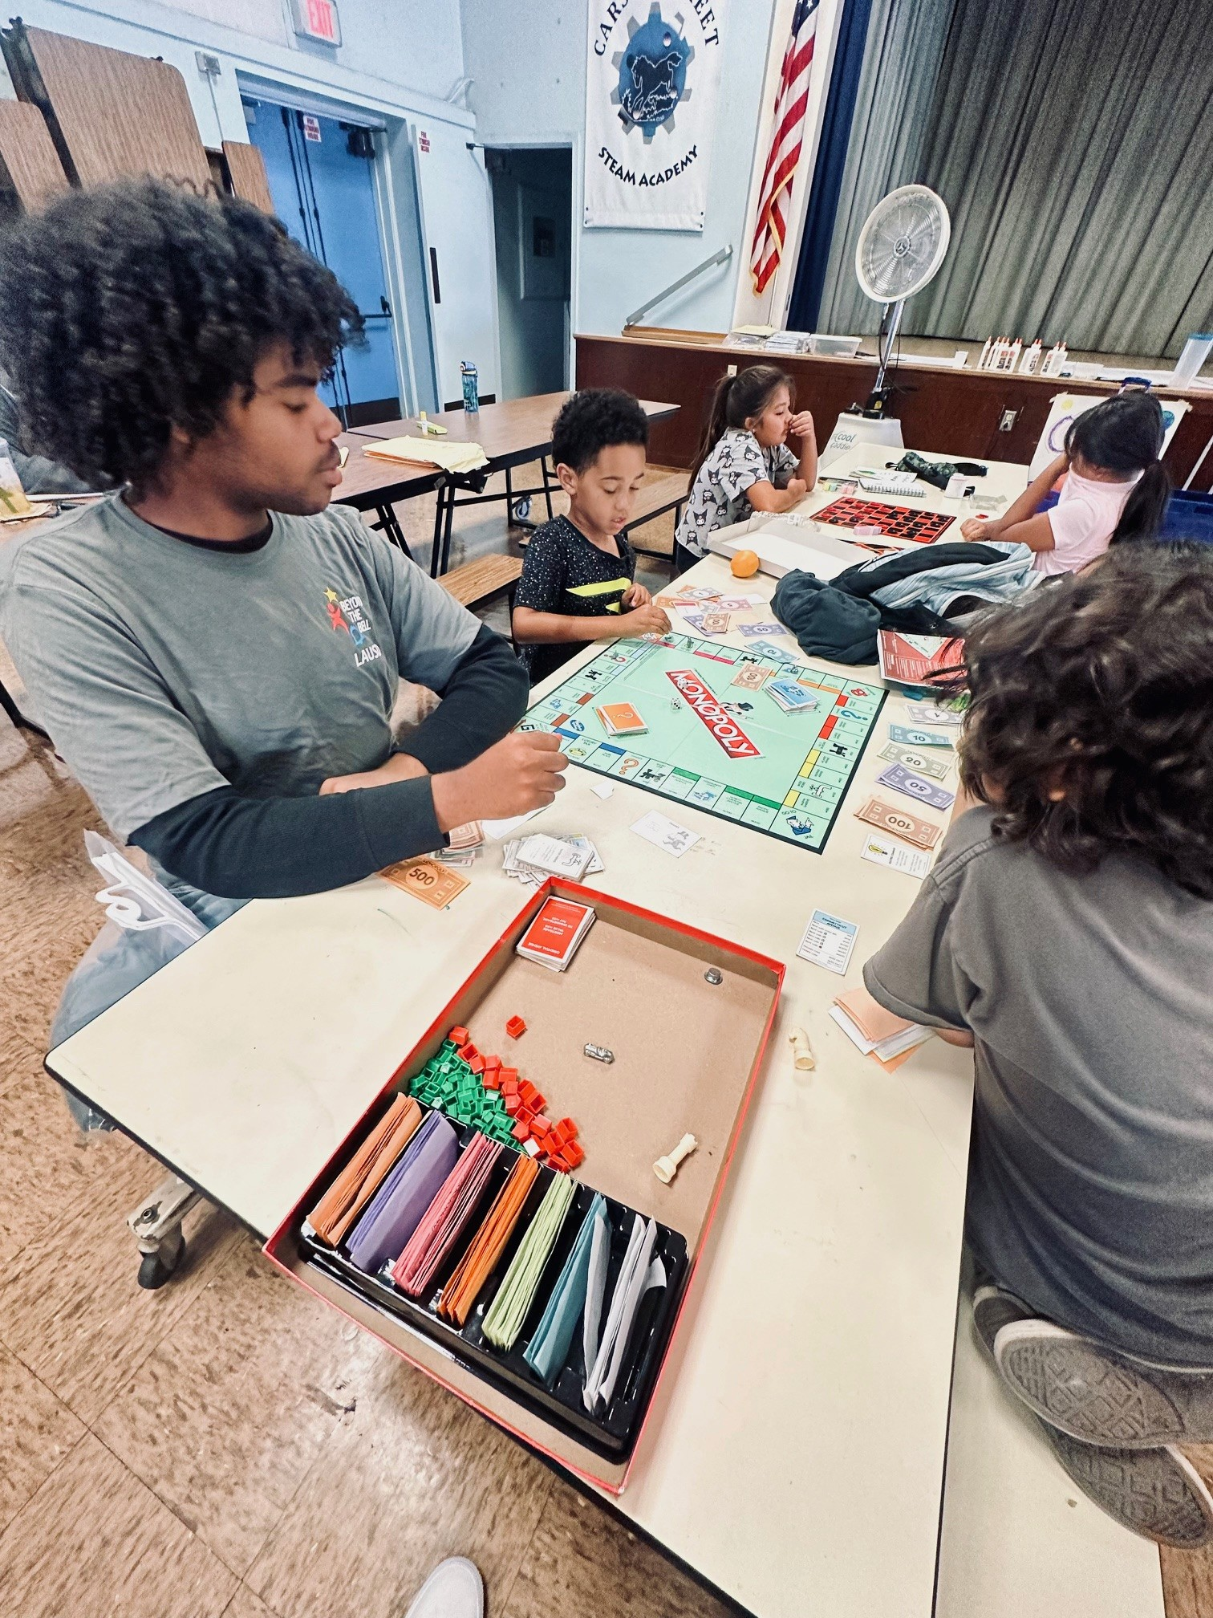
For more information, please contact @esther.dabagyan@lausd.net.

VIRTUAL ENRICHMENT

By participating in virtual enrichment, students have unlocked their summer potential for Optimal Growth. There were varied types of programs for every learner wanting to engage in enrichment activities. Thank you to all the students, teachers and coordinators that made this happen!

- 6,269 student enrollment for the virtual enrichment program (as of 7/19/24)

To see a list of virtual enrichment course offerings, visit: enrichment.lausd.net

CALIFORNIA STATE PRESCHOOL PROGRAMS (CSPP)
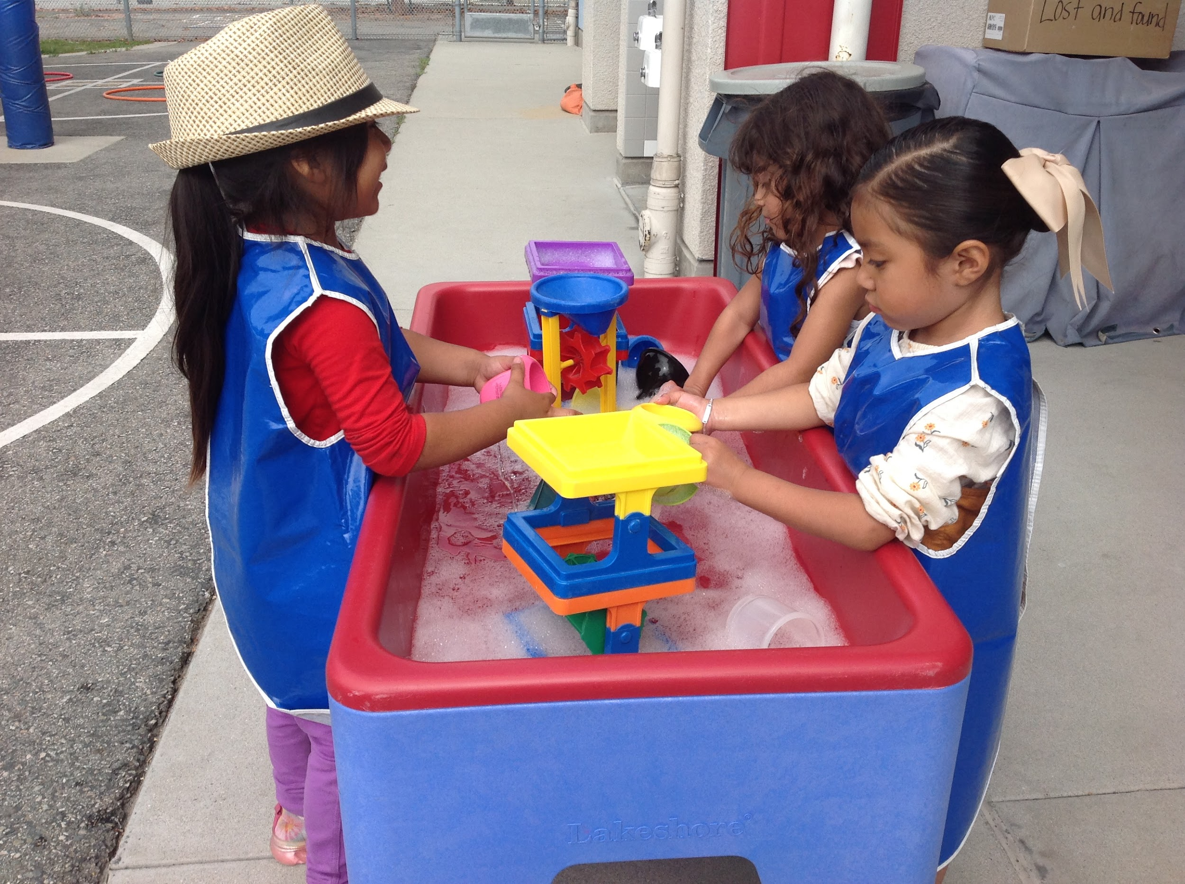
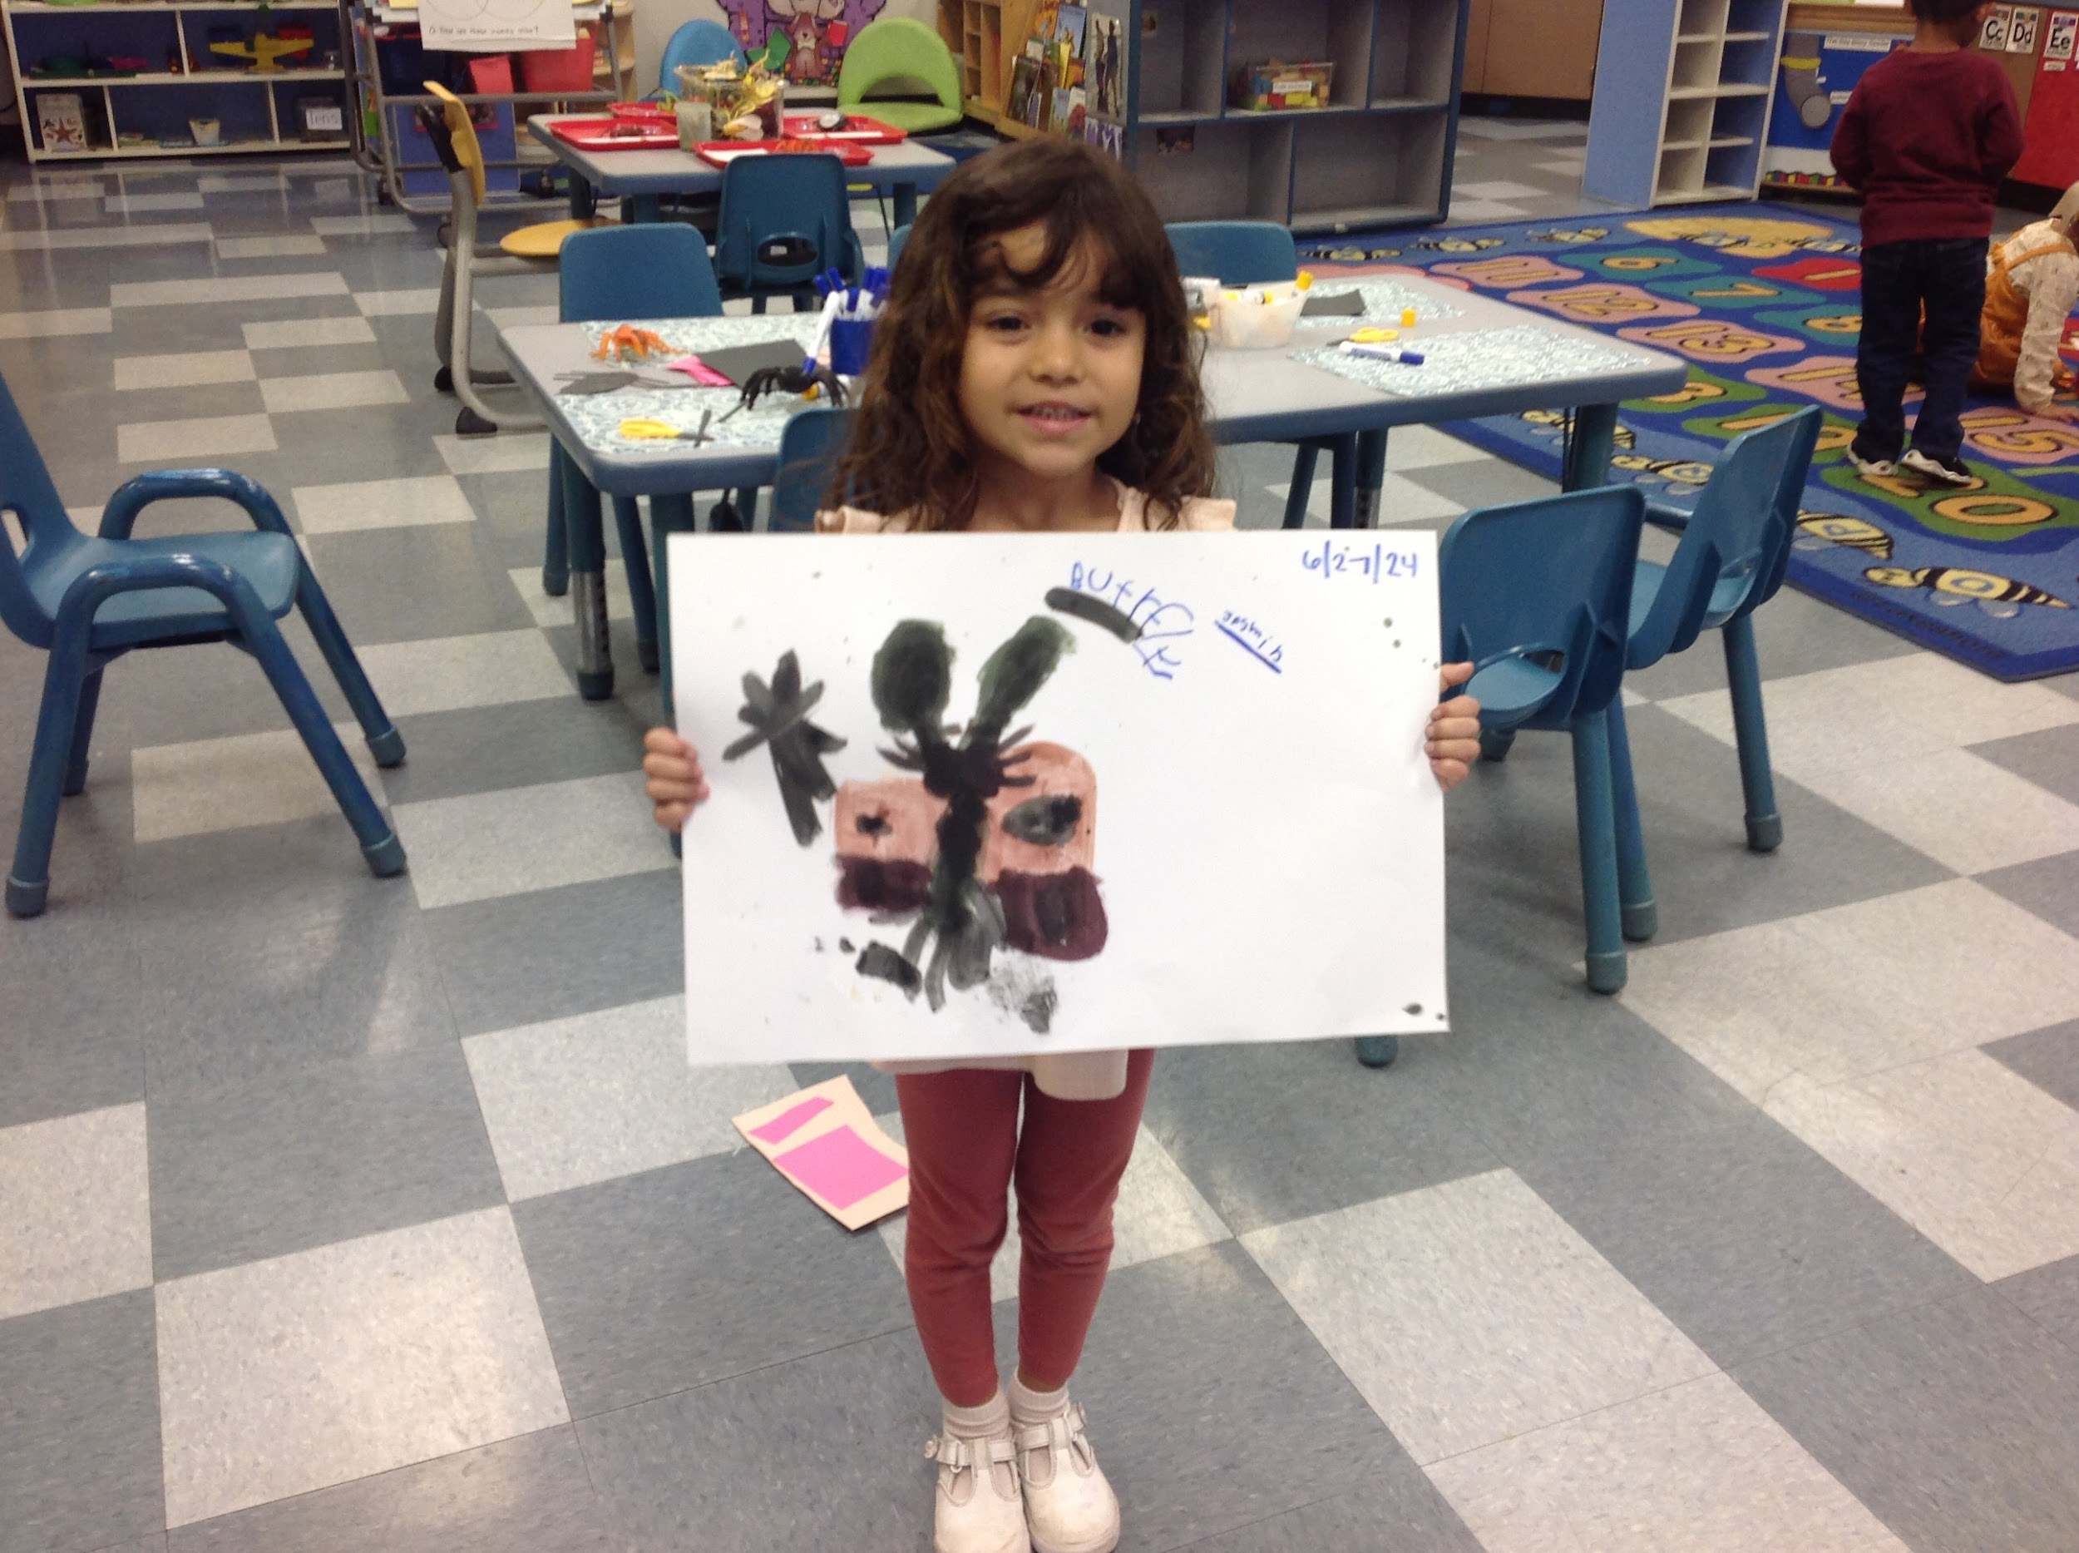
This summer, our CSPP preschoolers had an incredible time exploring the fascinating world of insects! From observing butterflies and ants to creating their own insect crafts, the children were fully engaged and excited about learning as they were exposed to “funtastic” hands-on activities that supported their oral language development. Parents expressed their gratitude for the extended school year, which not only provided valuable childcare but also enriched their children's educational experiences as they continue to prepare for kindergarten in the Fall. Visiting classrooms across the District, we saw firsthand how consistent attendance played a crucial role in the students' development and enjoyment. A special thank you to our summer school principals and school administrative assistants for their support and attention. Host sites allowed our programs’ success. Special “Thank You” to Coliseum ES, De La Torre ES, Hamasaki ES, Limerick ES, Plummer ES, Sheridan ES, and West Athens ES!
- 69 unique student enrollment for CSPP (as of 7/19/24)
- Attendance on 7/19/24 = 65

For more information, please Raul MORENO at ECED. rmore13@lausd.net, (213) 241-0157

*Source: ODA Summer 2024 PowerBI Dashboard

